

OSSP_Individual_

Hussnia Mohammed Yebrie_

bdu1601799

software engeenering_section b

Subdate;04/09/2017

To m.r wondimu baye

Table content

Introduction------------------------3

-Background----------------------3

-Motivation-----------------------3

Objective----------------------------4

Requirements------------------------5

Hardware requirement---------------6

Software requirement----------------7

Installation --------------------------9

Problems---------------------------33

Solution--------------------------38

File system support-----------------41

Advantage and disadvantage-------------43-

-Advantage-------------- --------43

-Disadvantage---------------------45

Conclusion----------------------------46

**. Future Outlook / Recommendation---50**

About virtualization-----------------55

Implementation of system call-----------58

A ,Introduction(background, motivation)

**Background and motivation**

Operating systems in the modern era do much more than start up a computer—they dictate how securely, efficiently, and flexibly we interact with hardware and software. Among all operating systems, NixOS stands out with its innovative configuration method, reproducibility, and package management. NixOS is different from other Linux distributions in that it uses a declarative configuration model and atomic upgrades, making it very stable, especially for development and production environments. As an OSSP student, my motivation to learn NixOS is fueled by its innovative design philosophy and everyday use in DevOps, system administration, and software deployment pipelines. With its focus on reproducibility and rollback safety, NixOS shatters traditional system management paradigms, offering a fresh and modern view of what an operating system is capable of. In addition, virtualization platforms like VMware Workstation or Oracle VirtualBox provide a segregated and secure place to experiment with such a robust platform. It provides me the freedom to experiment with the features of NixOS without affecting my primary machine, which is ideal for innovation and experimentation.

**b. Objectives**  
 The primary motivation for conducting this exercise is to get hands accustomed to the installation and setup of NixOS in a virtual environment. Not only does this exercise make me accustomed to practical uses of virtualization and OS installation, but also enhances my skill set in debugging problems, filesystem manipulation, and studying modern Linux distributions from user and system administrator perspectives.

I plan to achieve the following in this assignment:

* Learn how virtual machines simulate hardware platforms and how virtual machines facilitate testing with operating systems.
* Install NixOS from scratch with manual partitioning by hand and declarative configuration techniques well.
* Learn how to define user accounts, start services, and tailor configurations utilizing the unique Nix expression language.
* Gather and persevere through real-world installation or setup problems in a bid to foster technical resilience and problem-solving capability.
* Gain an understanding of the relevance of filesystem support, UNIX/POSIX conformity, and other standards applicable to modern system construction.
* Carefully document each step, so others (and myself, in the future) may easily replicate the same process.

Not only is this project furthering my OSSP training but also well positioning me for future career possibilities in system engineering, DevOps, or IT infrastructure where reproducible, sustainable systems like NixOS are increasingly desired.

**c. Requirements**  
Before the plunge into NixOS installation, understanding requirements—hardware and software—is a necessity. This is to ensure that the virtual machine works awesome and NixOS works as it should during and after its installation.

**i. Hardware Requirements**   
 Being a Linux operating system that installs systems in a different way, NixOS needs no super-duper-costly hardware—there simply just needs to be a good quality baseline for virtualized enjoyment.

| **Component** | **Minimum Requirement** |  | **Recommended Requirement** |
| --- | --- | --- | --- |
|  |  |  |  |
| **Processor (CPU)** | 2.0 GHz x86-64 processor (Dual-core or higher) |  | 3.0 GHz x86-64 processor (Quad-core or higher) |
| **RAM** | 4 GB RAM (Minimum for running virtual machine) |  | 8 GB RAM or more for smoother performance with multiple virtual machines |
|  |  |  |  |
| **Disk Space** | 20 GB free disk space for the virtual machine and OS |  | 40 GB or more to allow for additional software installations, VM snapshots, and updates |
|  |  |  |  |
| **Graphics** | Integrated graphics (Standard support for virtualized environments) |  | ADedicated graphics (for smoother GUI performance and enhanced graphics support) |
|  |  |  |  |
| **Network** | Stable Internet connection (for  downloading installation files and software packages) |  | High-speed Internet connection (for quicker download speeds and stable virtual machine performance) |
|  |  |  |  |
| **USB Ports** | USB 2.0 ports for transferring files between the host and guest OS |  | USB 3.0 or higher for faster file transfers and OS image management |

**ii. Software Requirements**  
To perform this installation, I employed the following software tools:

* **Virtualization Platform:**  
  ✅ Oracle VM VirtualBox (free and open-source)  
  *(or VMware Workstation, if that is your case—tweak accordingly)*  
  It provides a room for virtualizing a stand-alone machine where NixOS can be installed and tested without risks.
* **NixOS Installation ISO:**  
  ✅ Downloaded from the official NixOS website:  
  <https://nixos.org/download.html>  
  I employed the Graphical ISO (x86_64) flavor for simplicity and debugging purposes.
* **Snipping Tool or Screenshot Tool:**  
  ✅ Used to capture key steps while documenting the installation procedure.

**Optional Tools:**

* A minimalist text editor (e.g., Notepad, VS Code, or gedit) to write configuration files and notes.
* A PDF reader in order to have the NixOS manual available offline if the internet is unavailable.

| **Software** | **Version/Description** |
| --- | --- |
| **Oracle VM VirtualBox** | Version 6.0 or later for creating and managing virtual machines |
| **NixOS ISO Image** | Latest stable version of NixOS (available from the official NixOS website) |
| **Operating System (NixOS)** | NixOS (Linux distribution with declarative configuration model) |
| **Host Operating System** | Any UNIX-like system (Linux, macOS, or BSD) or Windows (with VirtualBox support) |
| **C Compiler (GCC)** | GCC 8.0 or higher for compiling C programs (e.g., ftruncate()) |
| **GNU Core Utilities** | Includes essential UNIX tools like ls, cp, mv, etc. |
| **POSIX Compliant Shell** | Bash, Zsh, or any other POSIX-compliant shell for shell scripting and system commands |
| **Text Editor** | Nano, Vim, Emacs, or Visual Studio Code for editing configuration files and scripts |
| **Network Tools** | curl, wget, ssh (for downloading NixOS installation files, software packages, and remote access) |
| **Optional: VM Tools (Guest Additions)** | For enhanced integration between host and guest OS in VirtualBox (supports shared folders, clipboard sharing, etc.) |

**INSTALLATION OF NIXOS STEPS**

Bottom of Form

### **1. Preparation: Download and Set Up Virtualization Environment**

Before installing NixOS, we need two things: the NixOS installer ISO and a virtualization tool. So we first download the nixos from google chrome

#### step 1.: Download NixOS ISO

* Go to the google chrome and type nixos linux download:

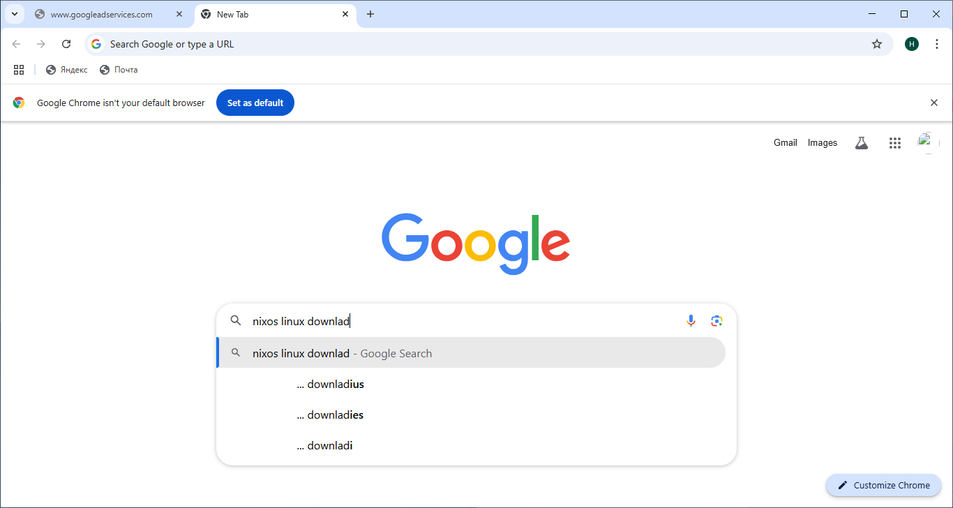

* Step 2: Go to the official NixOS download page:
* 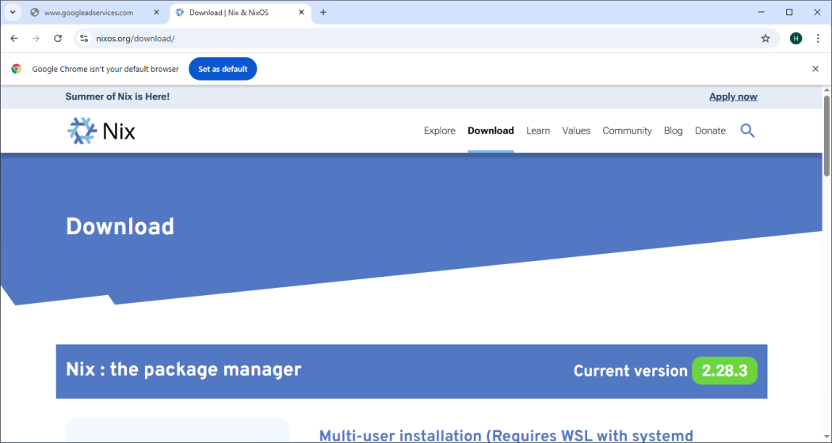
* Step3: Click to <https://nixos.org/download.html> 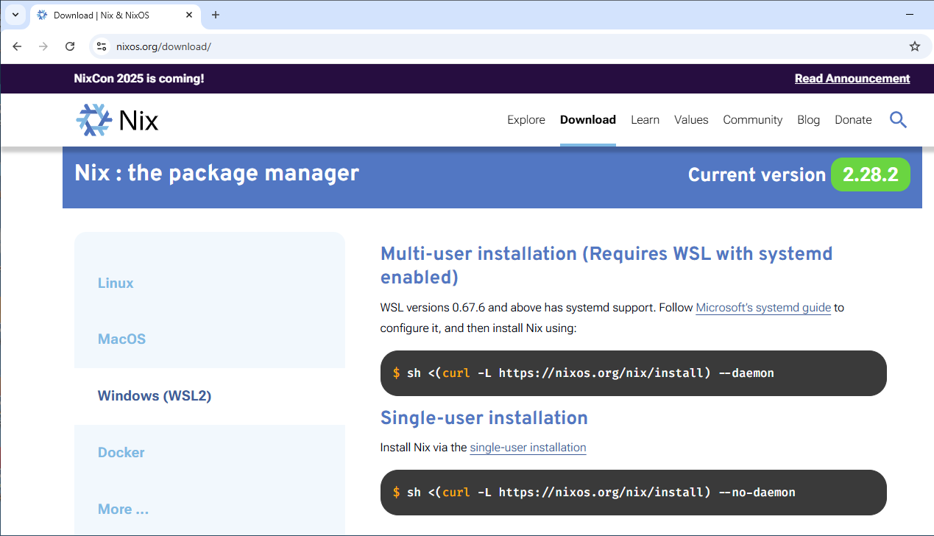

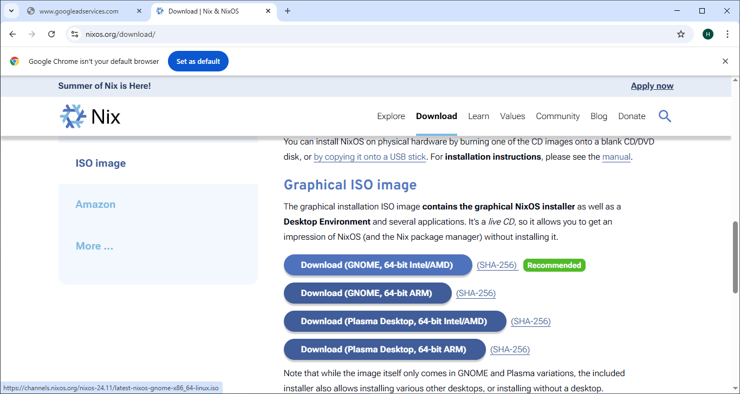

* Step 4: Choose the **Graphical ISO** (for GUI installation) or **Minimal ISO** (for terminal installation) based on your preference. But I prefer to install graphical iso.
* Download the appropriate ISO file for **x86_64 (Intel/AMD 64-bit)**.

Click to Download (GNOME,64bit Intel/AMD) because it is recommended by developers .

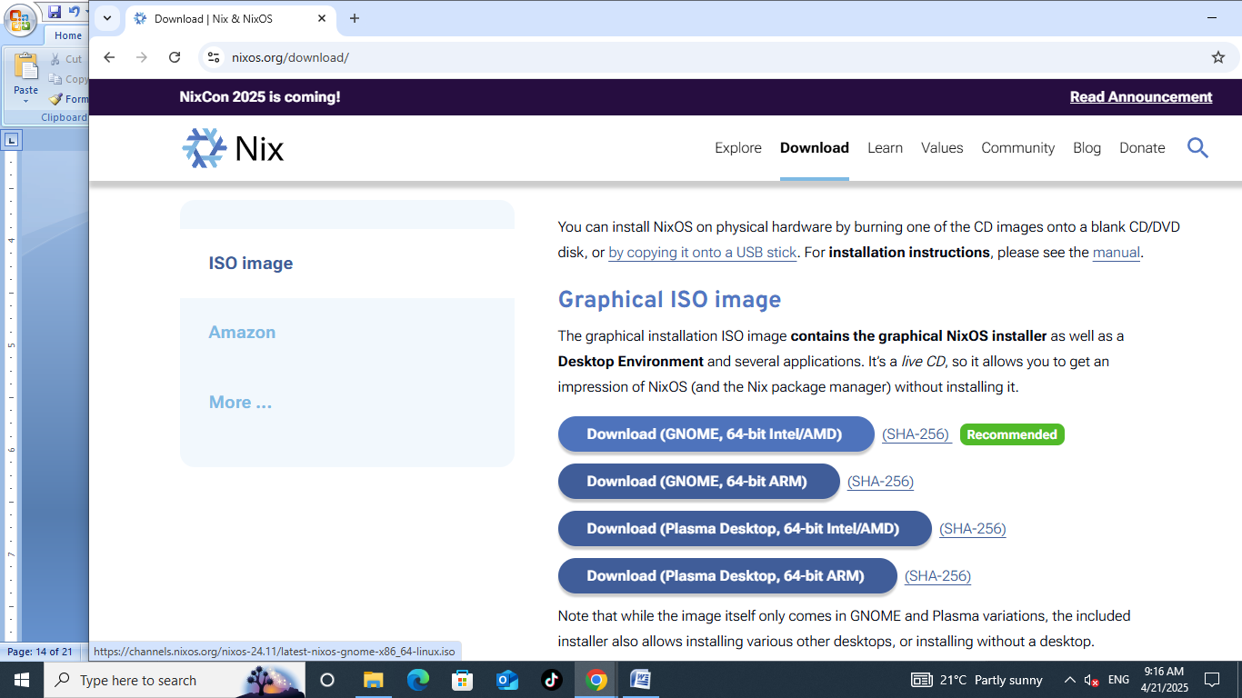

* Then authomatically download the computer it is 2.5 giga byte.

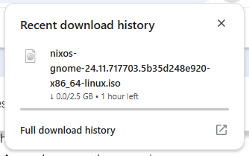

#### Step 1.2: Install Virtualization Software

We can use either:

* **VMware Workstation** I prefer vmware workstation over oracle

because there performance and GUI are easy to work .

* Step 1:Like the nixos we first enter to the google chrome website then type vmware workstation pro 17 download

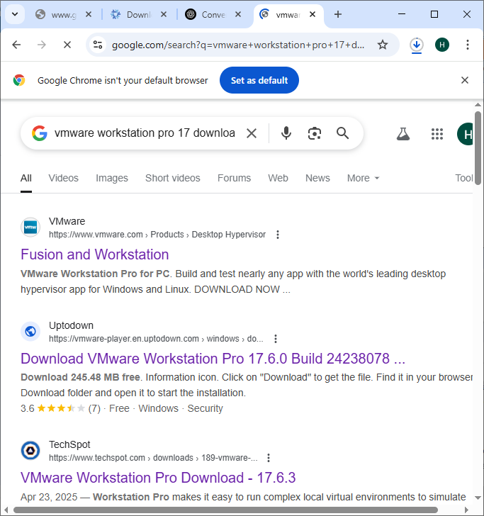.

* Then click the TechSpot website

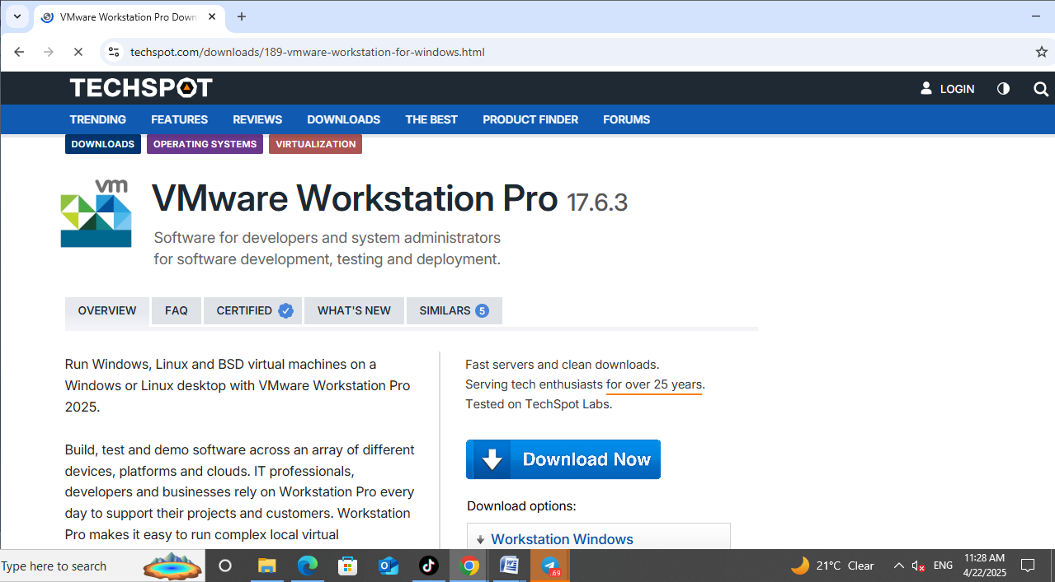

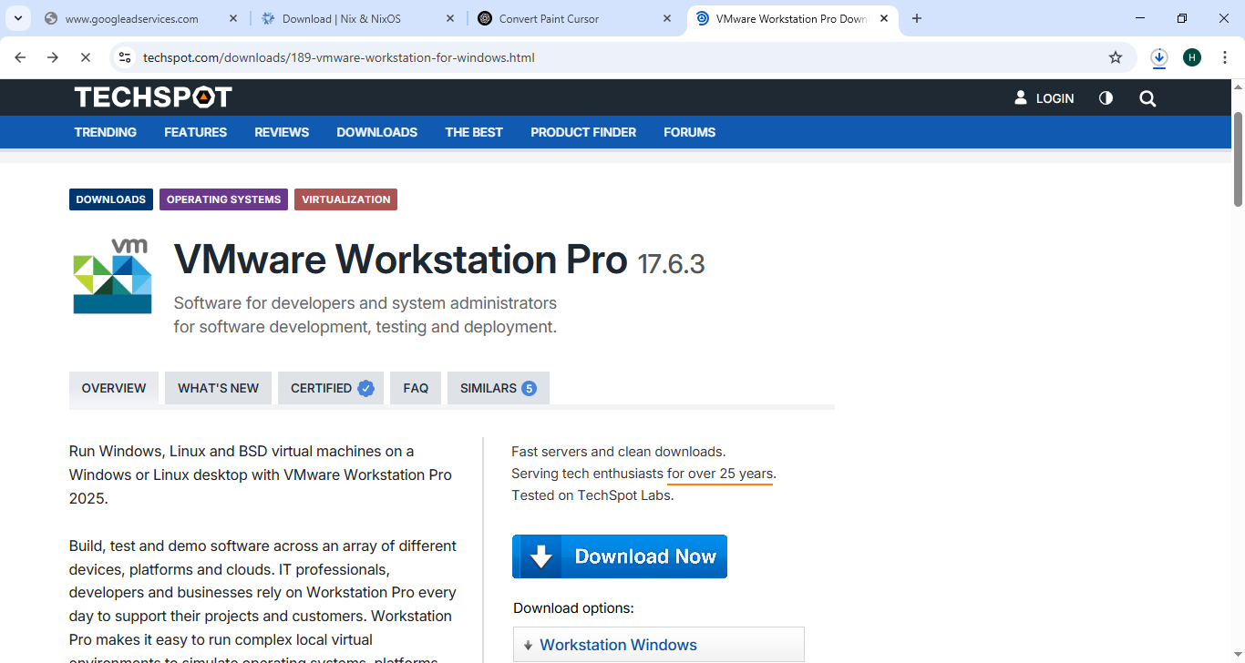

* Step 2 :Click in te download options the workstation for windows

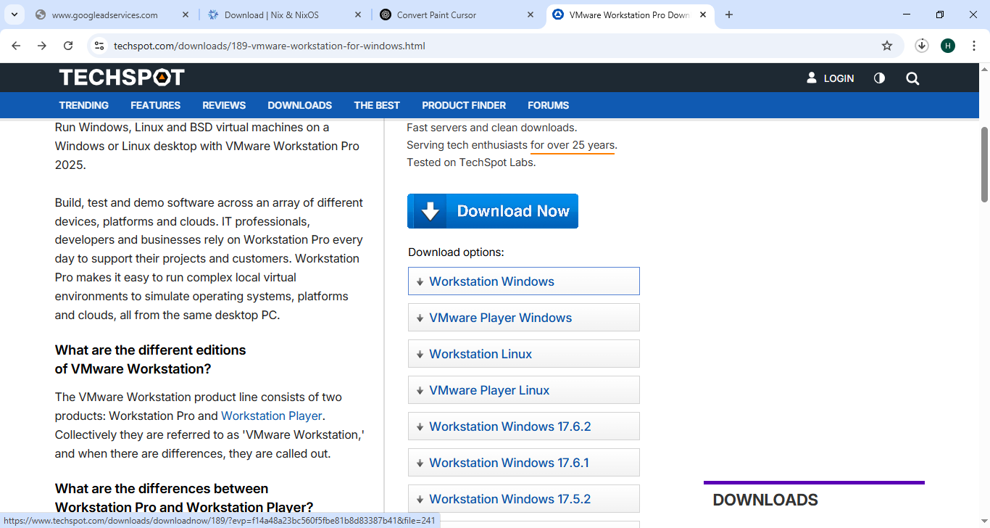

* Then click the download option

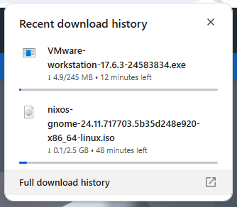

* Then install it finally it is found on the desctope like this

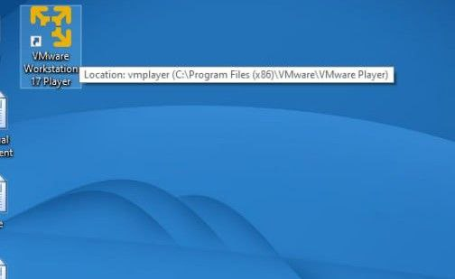

* **If we prefer Oracle VM VirtualBox** (free and lightweight)
* There is another option that the vmware is not working it is oracle

Install your chosen tool on your host operating system.

### 🟩 **2. Create a New Virtual Machine**

#### ✅ Step 2.1: Open your virtual machine software

* Launch **VMware Workstation** or **VirtualBox**.

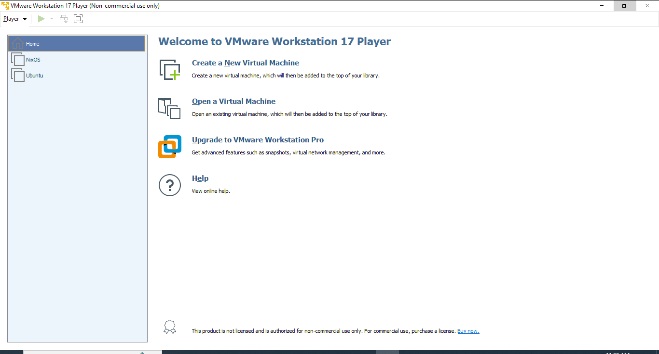

#### ✅ Step 2.2: Create a New VM

##### In VMware:

* Click **“Create a New Virtual Machine”**



* Choose **Custom (Advanced)** installation
* Set compatibility (use default)
* Choose “Installer disc image file (ISO)” and select the **NixOS ISO**

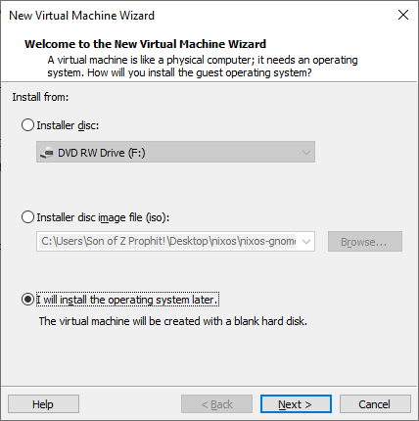

* Set OS type: **Linux → Other Linux 5.x or later kernel 64-bit**

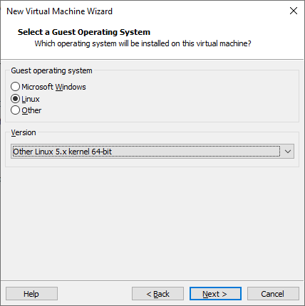

* Give the virtual machine name as nixos and the location the click next

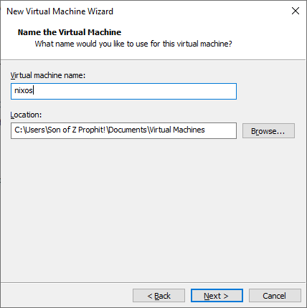

Allocate CPU cores (2+ recommended), memory (at least 2048 MB RAM), and disk (20 GB+)

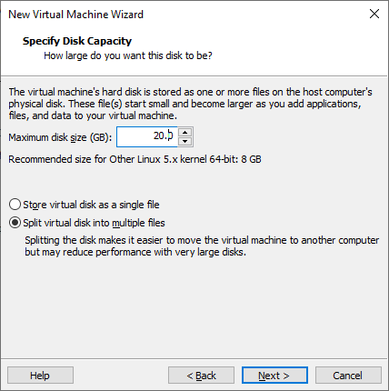

**Finally the operating system is entered to vmware workstation.**

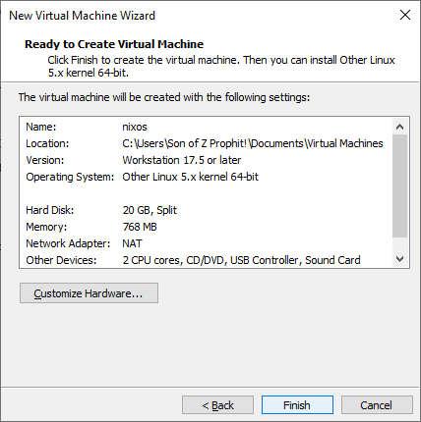

**And the operating system put like this in the left side of the vmware**

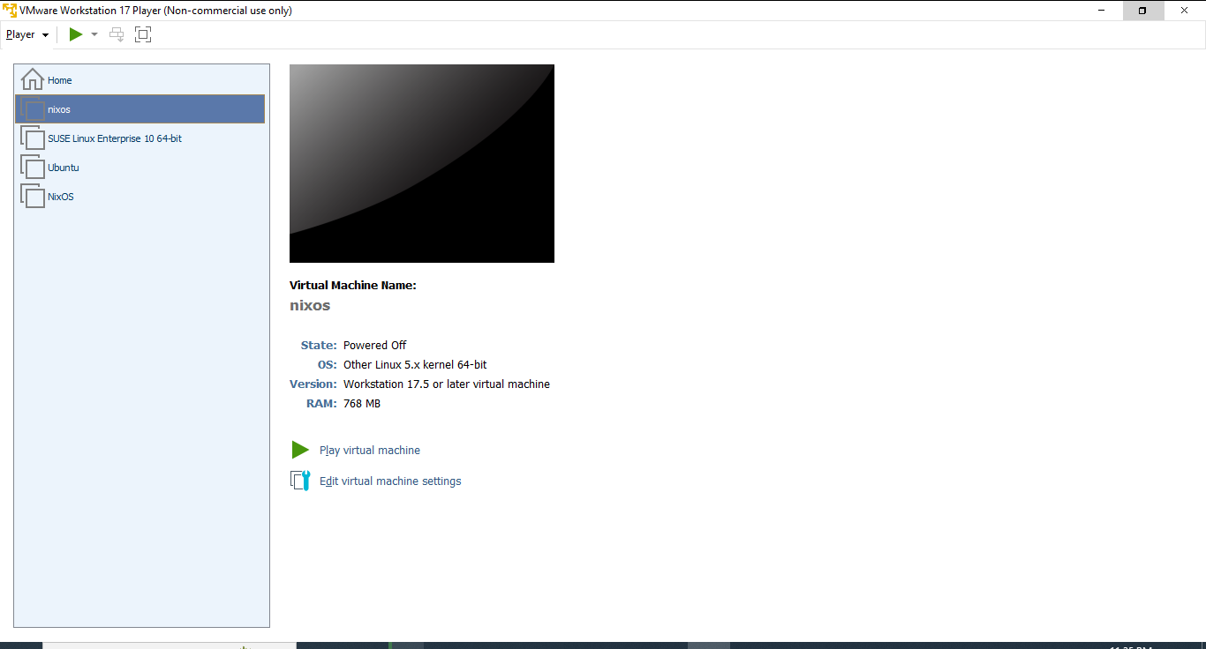

. then click on the nixos

##### In VirtualBox:

* Click **“New”**
* Name: NixOS
* Type: **Linux**
* Version: **Other Linux (64-bit)**
* RAM: **2048 MB or more**
* Create a virtual hard disk (VDI), size: **20 GB or more**

**This step is provide for other persons that use virtualbox over vmware workstation i mentioned in the previous I select vmware workstation so I do not use this step.**

#### Steps to install the nixos on the vmware workstation

Start the vmware and click the nixos



Start the virtual machine by click play in the left corner.

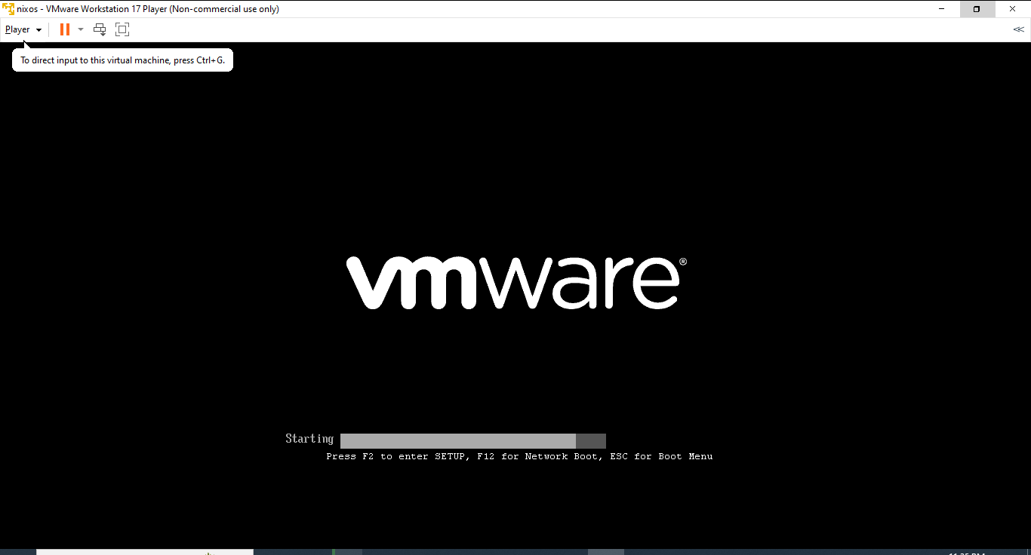

Then authomatically boot the nixos

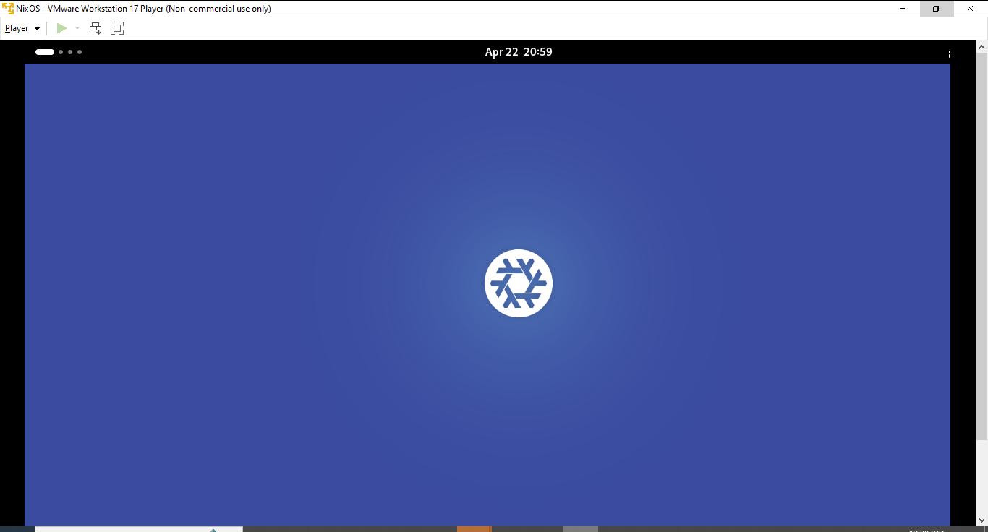

* It will boot into the **NixOS Live Terminal Interface** (if minimal ISO), or a **desktop environment** (if graphical ISO).

#### Check available disks

In the terminal, type:

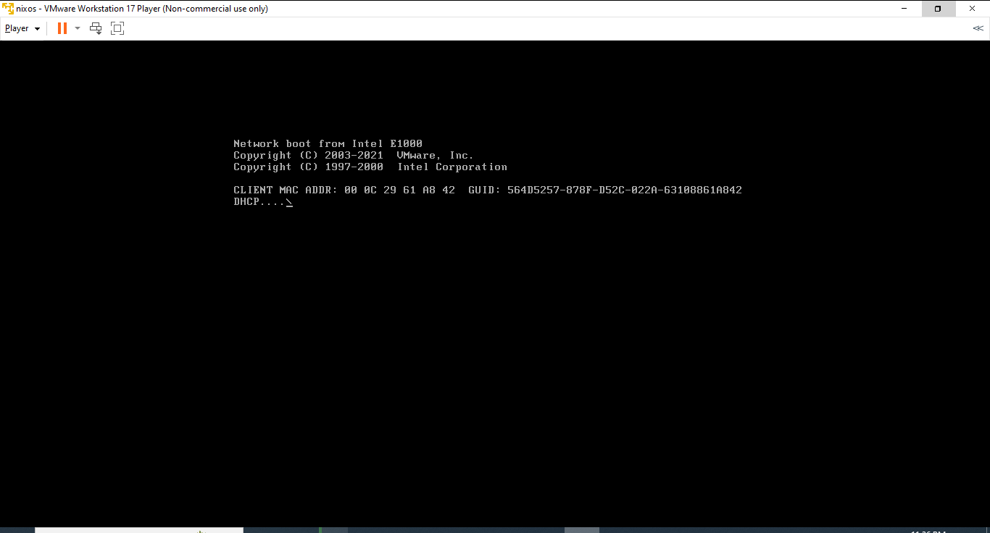

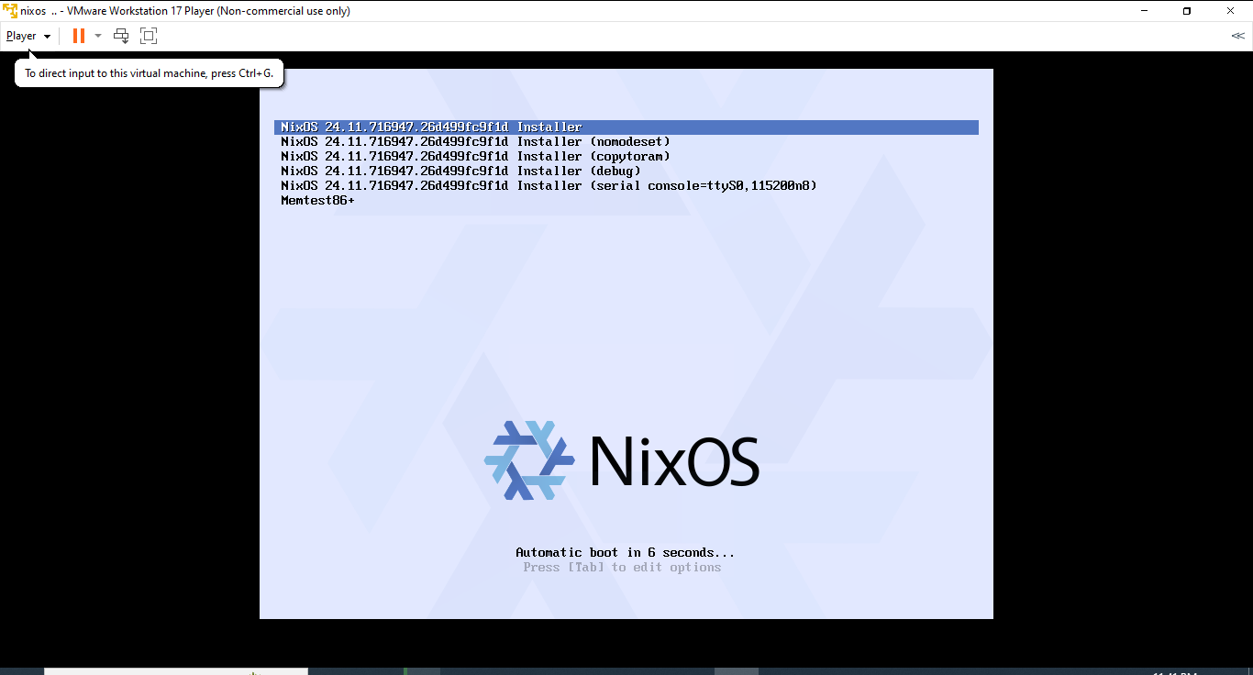

### **3. Boot into the NixOS Live Environment**

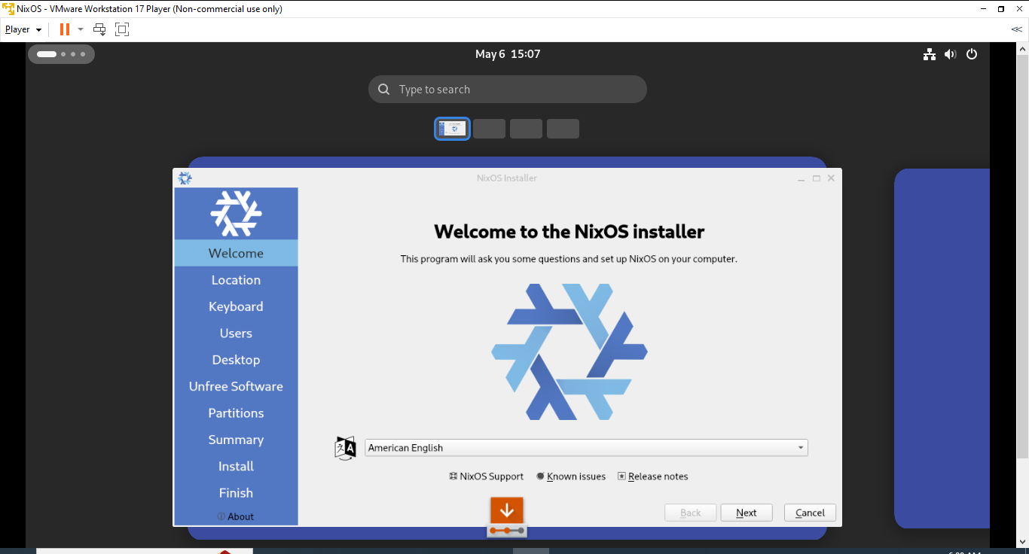

#### ✅ Open the configuration file

#### ✅ Add the following basic configuration

|  |
| --- |
| {  imports = [ ./hardwssare-configuration.nix ];  boot.loader.grub.device = "/dev/sda";  networking.hostName = "nixos";  time.timeZone = "Africa/Addis_Ababa";  i18n.defaultLocale = "en_US.UTF-8";  networking.useDHCP = true;  users.users.hussnia = {  isNormalUser = true;  extraGroups = [ "wheel" ]; # Enable sudo  password = "yourpassword"; # replace with real password  };  environment.systemPackages = with pkgs; [  wget  vim  firefox  ]; |

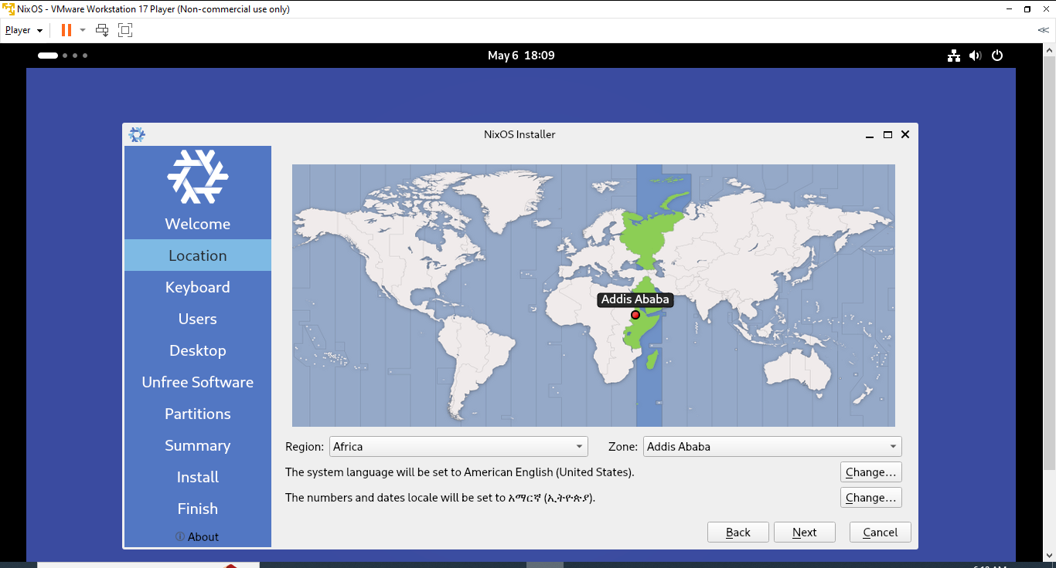

Then change the keyboard

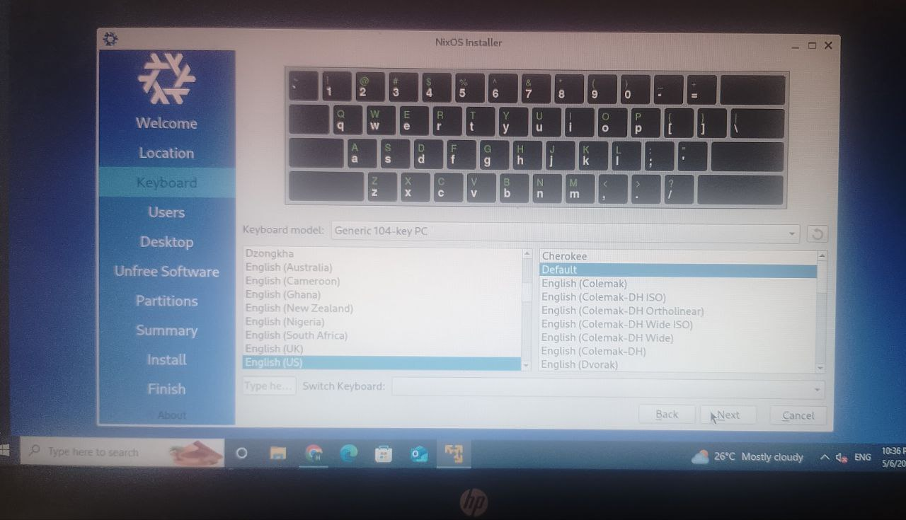

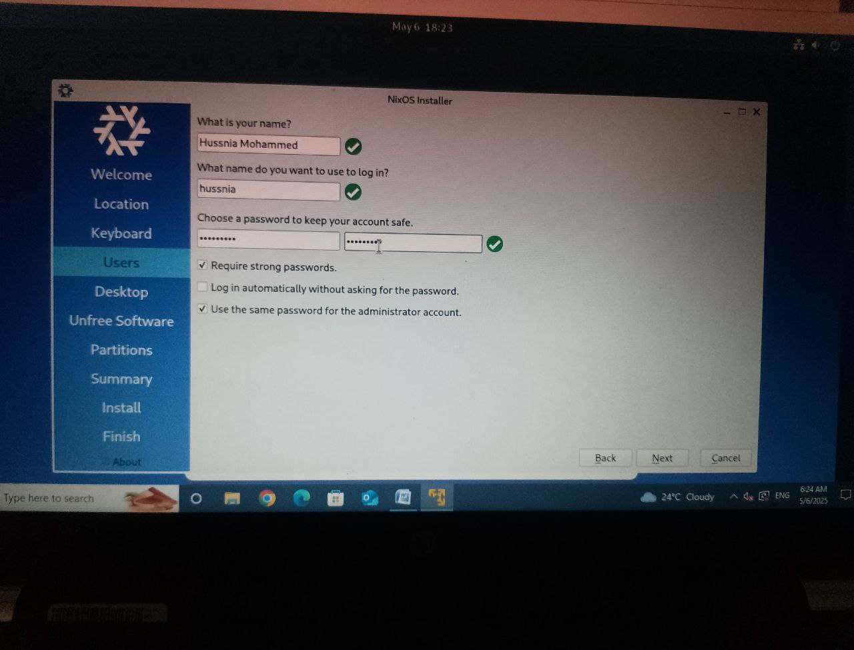

It will boot into the **NixOS Live Terminal Interface** (if minimal ISO), or a **desktop environment** (if graphical ISO).

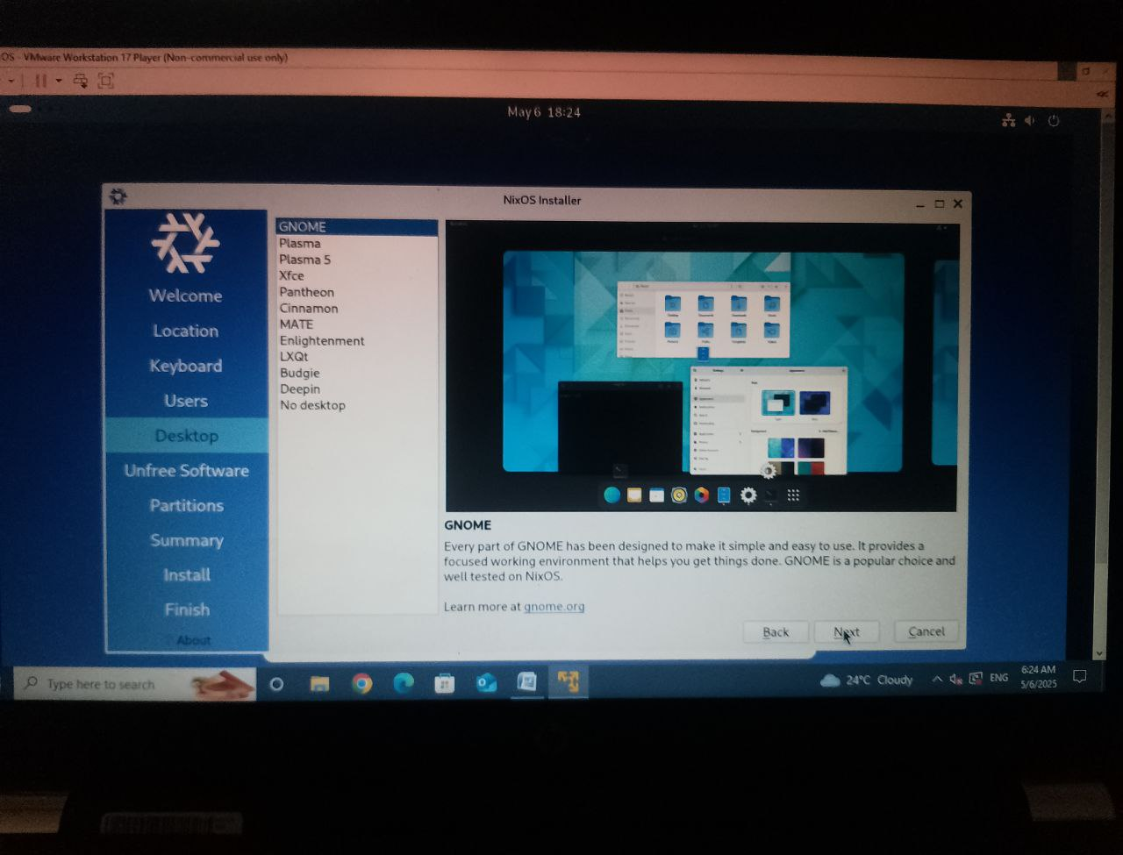

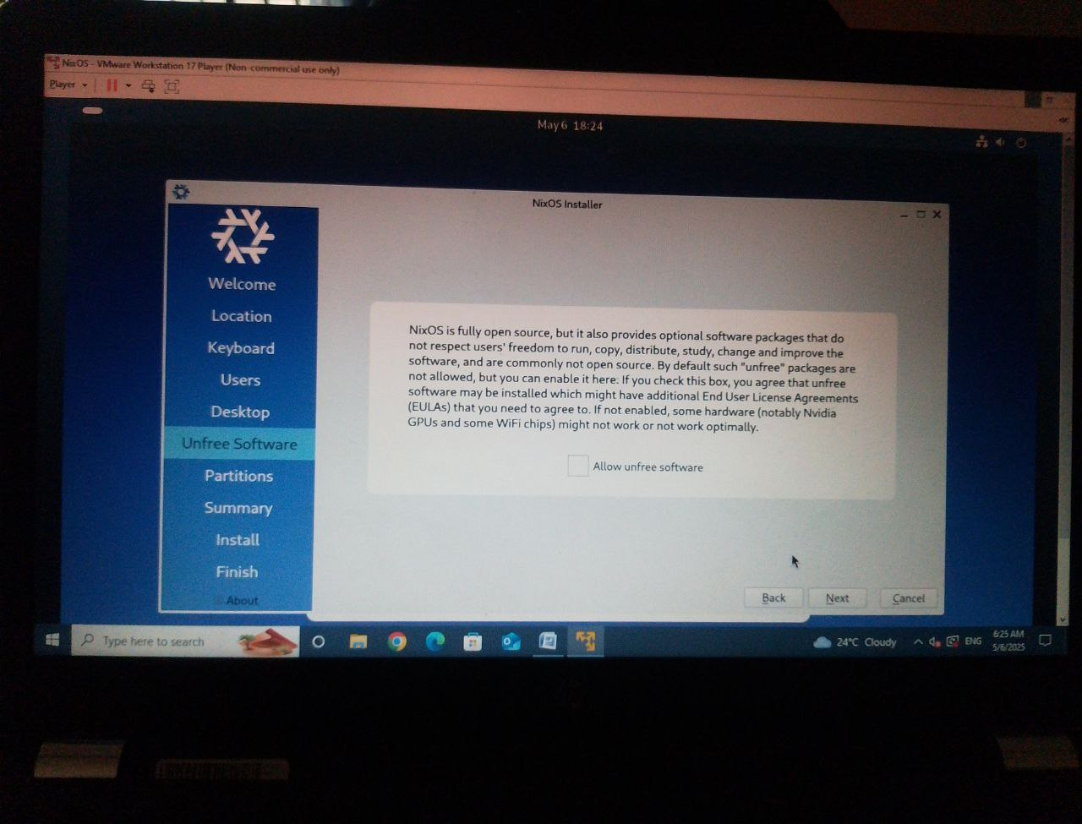

### 🟩 **4. Partition and Format the Disk**

For this guide, we assume you’re installing on a clean disk /dev/sda.

#### ✅ Step 4.1: Create a partition table and format

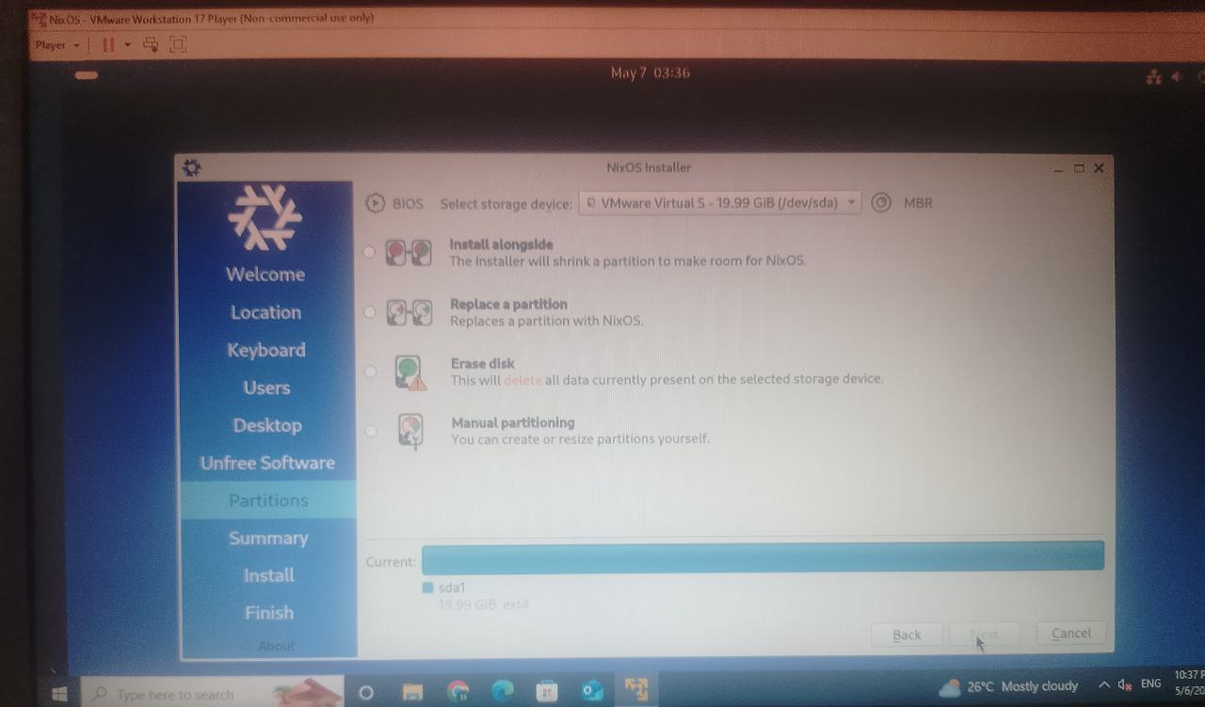

|  |
| --- |
| Bash  CopyEdit  parted /dev/sda -- mklabel msdos  partessd /dev/sda -- mkpart primary ext4 1MiB 100%  mkfs.ext4 /dev/sda1 |

#### ✅ Step 4.2: Mount the partition

### **5. Generate the NixOS Configuration**

Now we generate the default configuration files needed to install NixOS.

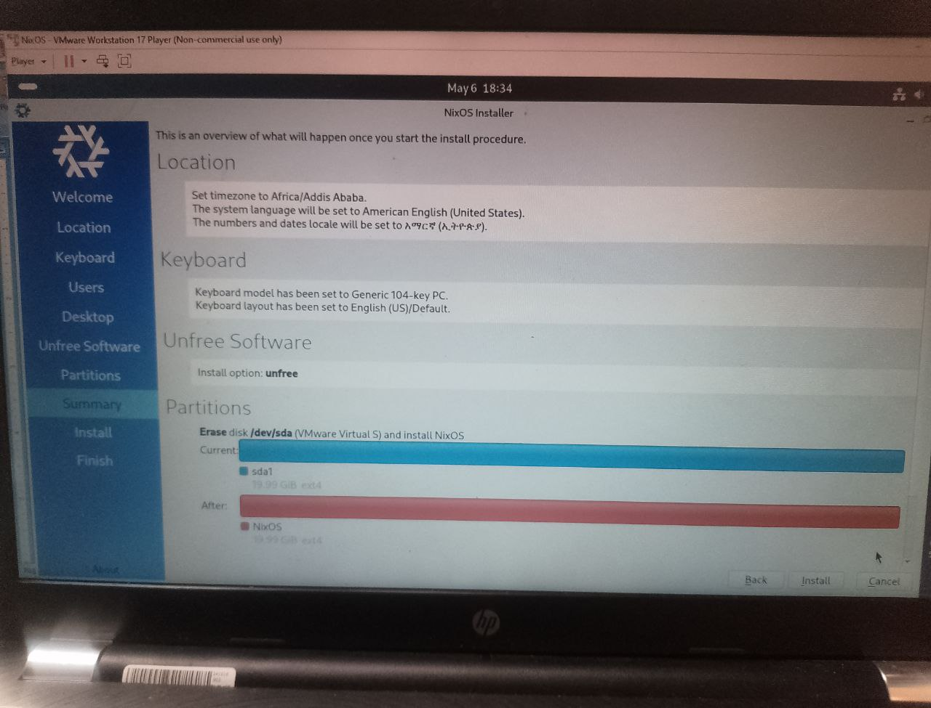

**. Install NixOS**

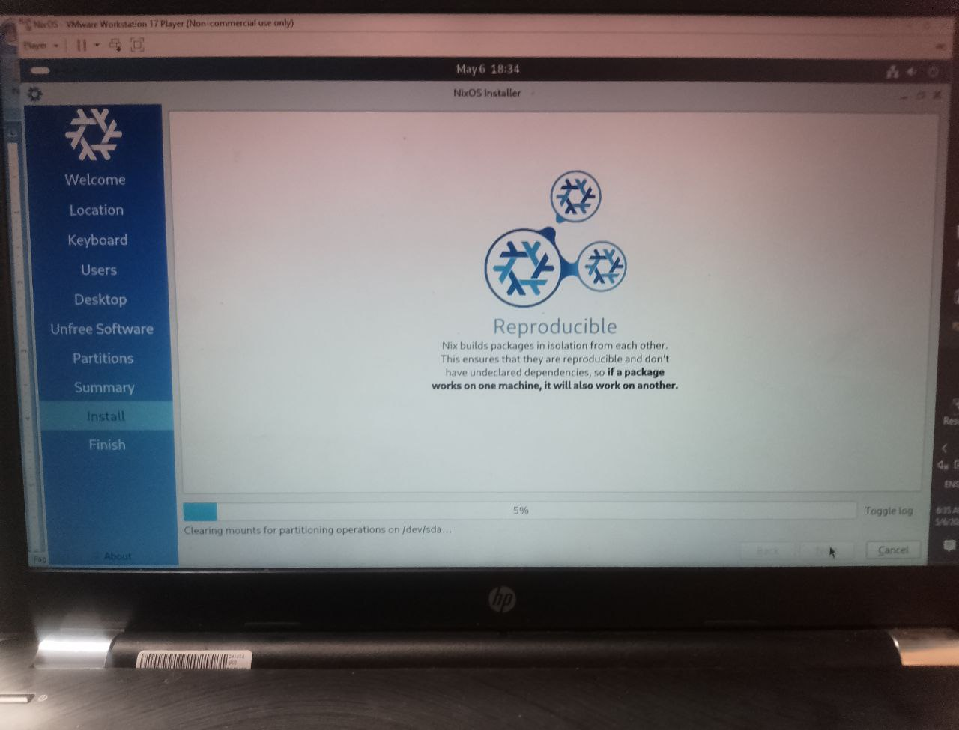

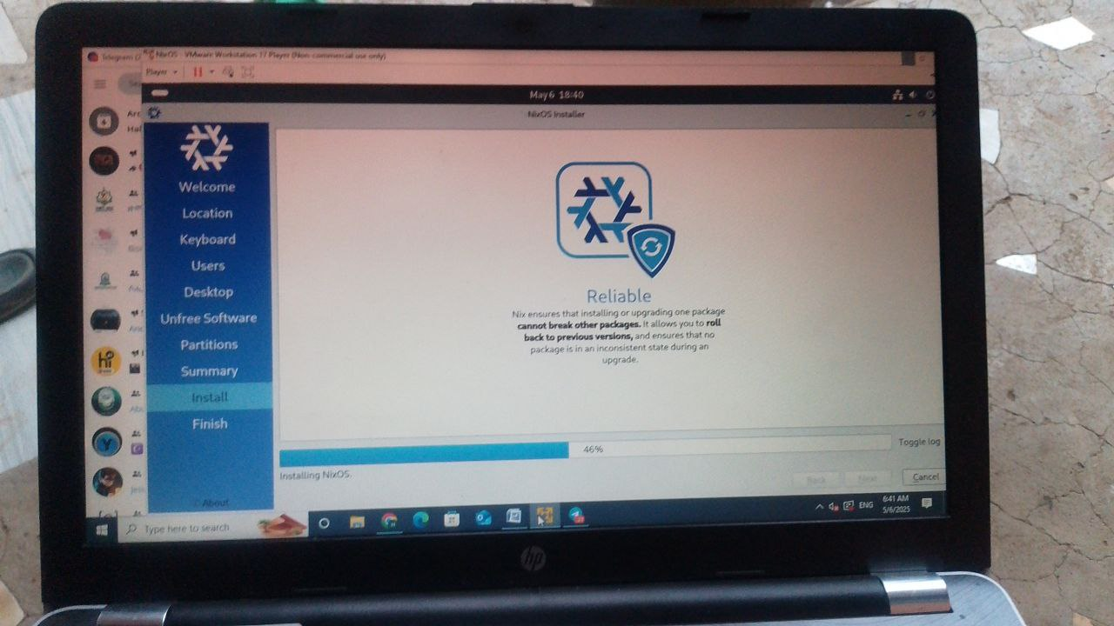

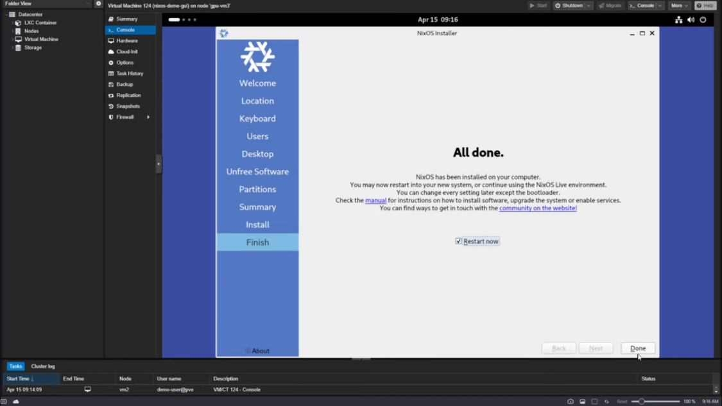 Apply your settings from configuration.nix 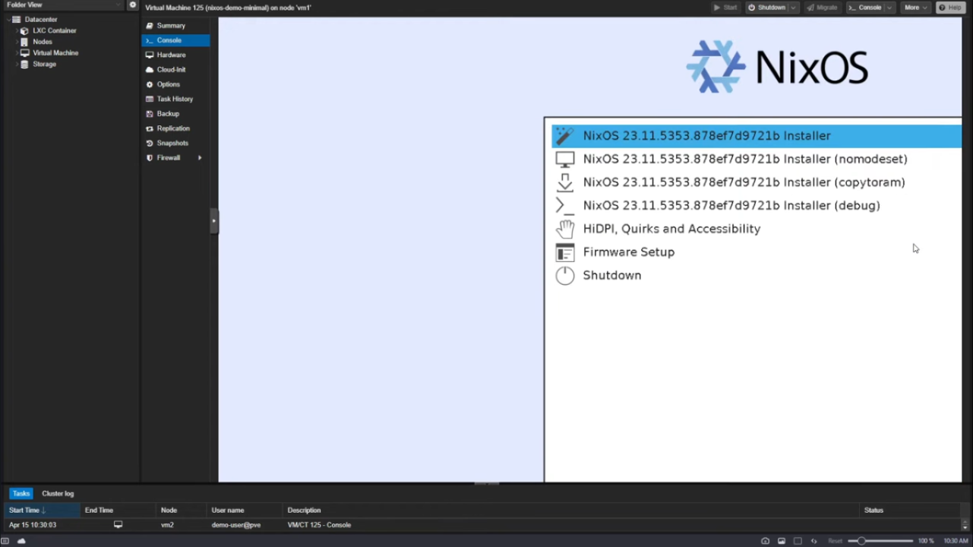

* **Reboot and Start Using NixOS**

#### Step 8.1: Unmount and reboot

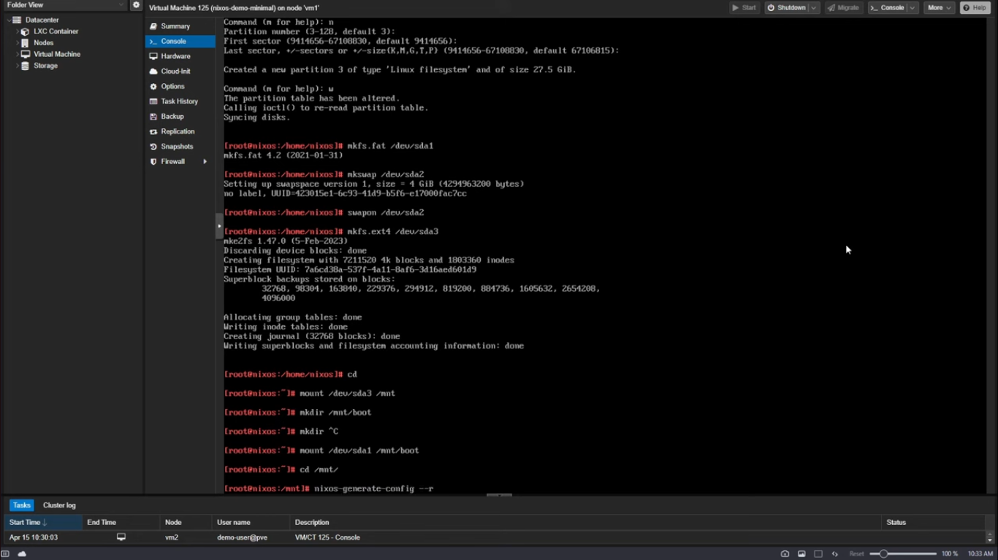

#### Step 8.2: Remove the ISO

* Before the system reboots, **detach the NixOS ISO** from the virtual CD/DVD settings in your virtualization tool.

Your system should now boot directly into **NixOS**!

### **Post-Installation Tasks**

#### Log in

Use the username and password you configured in configuration.nix (e.g., hussnia 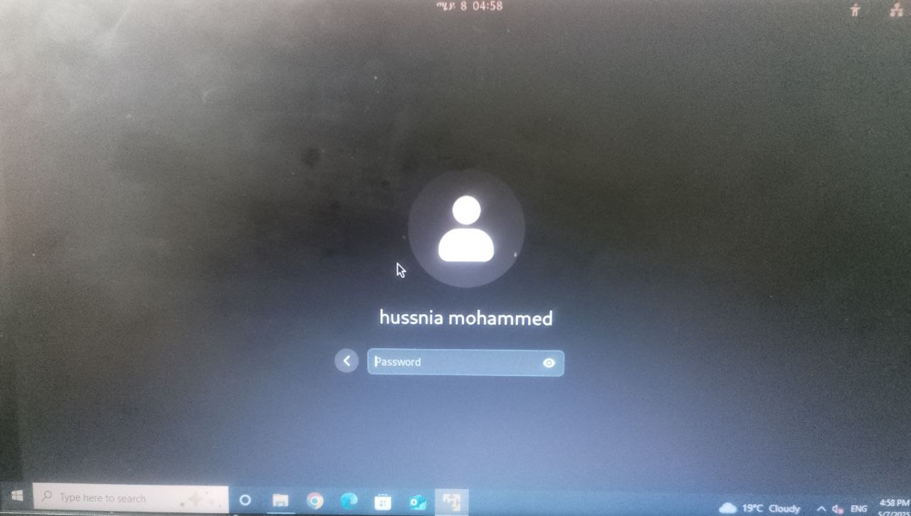

### **Summary of Installation Steps**

* **Set up a virtual machine** in **VMware Workstation** or **VirtualBox**.
* **Partition the disk** and mount it to /mnt.
* **Generate and edit the configuration files** in **/mnt/etc/nixos/**.
* **Install NixOS** using the **nixos-install** command.
* **Reboot the VM** and remove the ISO to boot into the newly installed NixOS.
* Perform **post-installation tasks** like **user creation** and **enabling services**

## **Issues (Problems Faced)**

During the installation of **NixOS using VMware Workstation**, multiple technical challenges were encountered due to **hardware limitations**, **operating system complexity**, and **virtualization performance issues**. Below is a comprehensive list of issues faced, supported with explanations and suggestions for screenshots (snipped images).

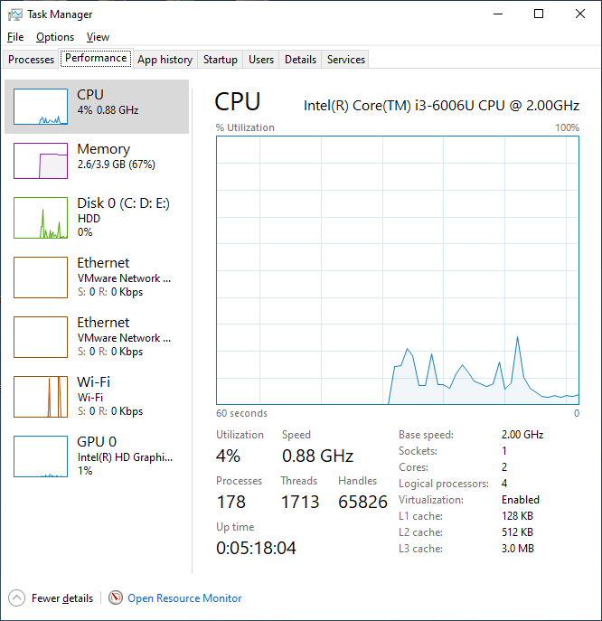  
**Figure 1:** VMware RAM allocation window + system RAM from Task Manager

### **Issue 2: Graphical Installer Fails to Load or Freezes**

* After selecting the **Graphical NixOS ISO** and booting the VM, the system froze at:
  + A black screen after boot logs
  + Or during the X Window startup process
* Possible causes:
  + VMware’s default graphics settings may not be optimized
  + Low VRAM and memory lead to kernel panic or unresponsive graphical shell

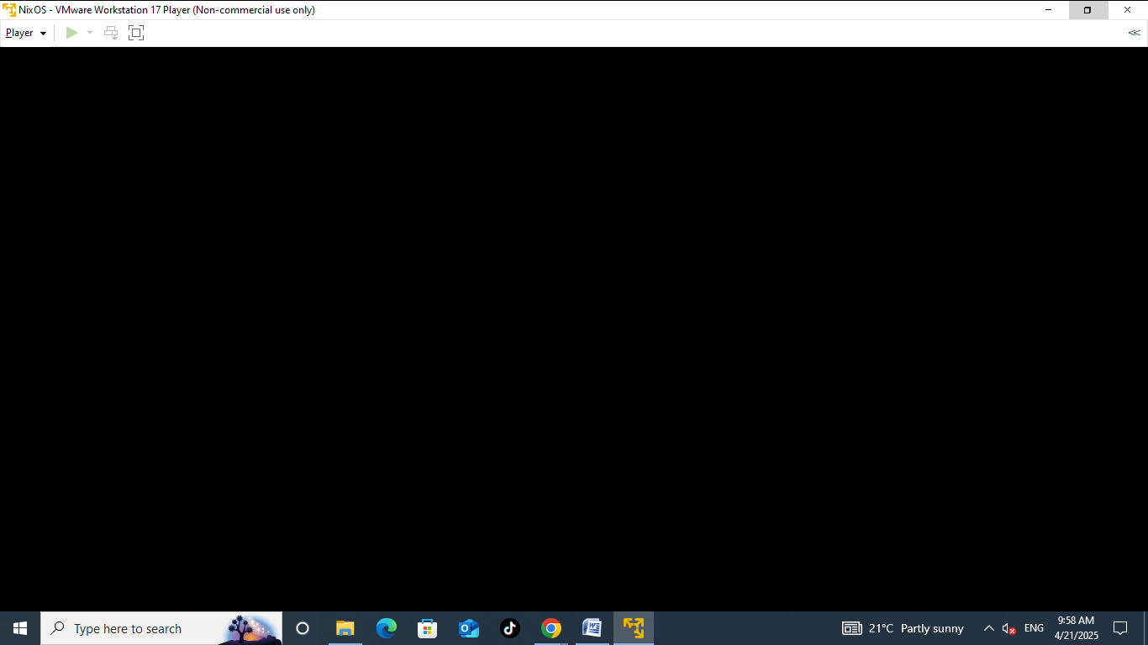  
**Figure 2:** Screenshot of black screen or freeze point after boot

**1,Virtualization Mode Disabled in BIOS**

* + My computer had virtualization (VT-x/AMD-V) disabled by default, which is required for running 64-bit virtual machines.
  + As a result, I can not use vmware workstation then I wached different supported video to work it.
  + Accessing BIOS was confusing because different systems use different keys (F2, Del, Esc, etc.).

1. **Limited Hardware Resources**
   * My PC has limited RAM (e.g., 4GB) and an Intel Core i3 processor, which made running virtualization tools slow.
   * When I started the VM, the system performance dropped significantly, sometimes freezing completely. 
   * NixOS installation in the VM required more memory and CPU than my machine could comfortably provide.
2. **High Download Size for NixOS ISO and Virtualization Tools**
   * The NixOS ISO file size is about 1.3 GB to 2.5 GB depending on the version.
   * VMware Workstation or VirtualBox setup files are also large (~500MB or more).
   * Slow internet and limited data made it hard to download these files in one session.
3. **Difficulty Locating or Identifying ISO File**
   * After downloading NixOS, the file did not clearly show the .iso extension instead it shows icnk file extension and it is hard to get the iso file extension.
   * In some file explorers, extensions are hidden by default, making it hard to identify which file to use for the virtual machine.
   * I also downloaded a wrong file version at first I download the wrong Minimal ISO due to confusion on the official site but I should the Graphical ISO.
4. **Screenshot Tools Not Working**
   * I had difficulty using built-in tools like **Snipping Tool** or **PrtScn**, especially while working in full-screen VM mode.
   * Capturing installation steps accurately was difficult, and I sometimes lost screenshots after saving.
5. **Hard to Allocate Disk Space**
   * My PC has two drives (C: and D:) with 166 GB and 206 GB, but both had existing files and limited free space.
   * I wasn't sure which drive to use, and allocating enough space (~10GB or more) for the virtual machine was challenging without deleting important data.
6. **Confusion During Partitioning in NixOS Installer**
   * NixOS does not provide a beginner-friendly graphical installer.
   * During the installation, I was confused by terms like /mnt, /boot, swap, and formatting with ext4.
   * Creating partitions manually inside the NixOS shell was not easy for beginners.
7. **Account Creation Issues**
   * The installer process required me to create a user account with my full name ("Hussnia").
   * NixOS uses Linux-style user creation, and spaces are not supported in usernames, which caused an error.
8. **No Internet Connection in VM**
   * After installation, the virtual machine had no internet access.
   * NixOS requires manual configuration for network settings, and I struggled to enable DHCP or use NAT networking properly.
   * 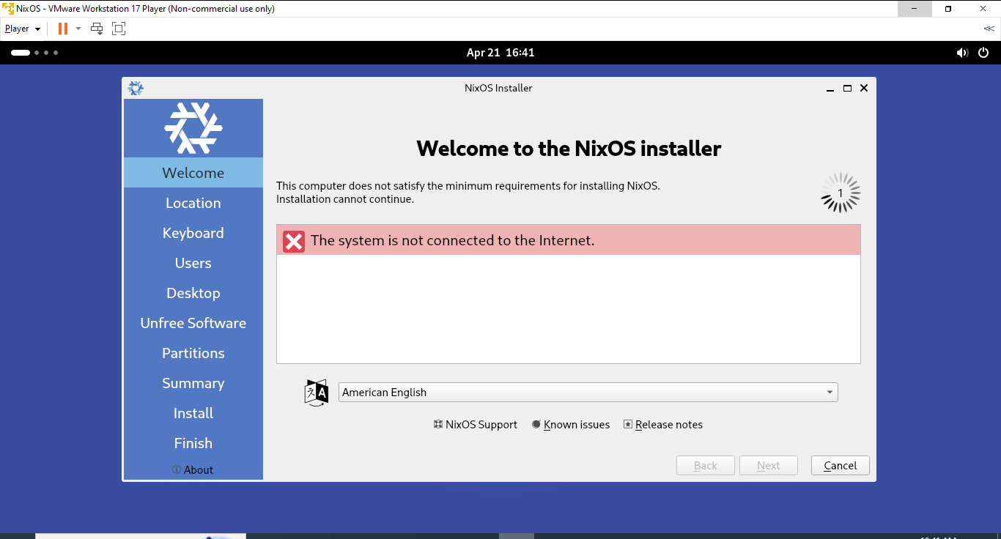

## **f. Solutions**

Here is how each of the above issues was addressed, using documentation, practical workarounds, and logical troubleshooting techniques

**1 ,Enabled Virtualization in BIOS**

* + I accessed the BIOS setup by entering to the setting< update and privacy < recovery<restart< then enter to BIOS using F2 or Del during startup.
  + Located the "Virtualization Technology" option under CPU or Advanced settings.
  + Enabled it, saved changes, and rebooted. After that, 64-bit options appeared in Vmware workstation.

**2,Optimized VM Settings for Low-End PC**

* + Reduced allocated RAM to 2048MB (2GB) to avoid crashing my host OS.
  + Set processor count to 1 and used virtualization acceleration settings like VT-x/AMD-V.
  + Disabled unneeded VM features (audio, USB, etc.) to improve performance.
  + And delete unnesessary files to get more free storages.

**3,Downloaded Files with Download Manager**

* + Used tools like **Internet Download Manager (IDM)** or browser extensions to resume interrupted downloads.
  + Scheduled large downloads at night when internet traffic was low to avoid disconnections.
  + Aud use campuse wifi.

**4.Manually Enabled File Extensions**

* + Opened File Explorer → View → checked “File name extensions” to see .iso clearly.
  + Renamed or verified the ISO before using it in VMware.

**5.Used Lightshot and VM Screenshots**

* + Installed **Lightshot**, a lightweight and easy-to-use screenshot tool.
  + Used VirtualBox's built-in screenshot tool (Devices → Take Screenshot) while the VM was running.
  + And I use the phone to capture the picture.

**6.Cleaned Up Disk Space**

* + Moved personal files (videos, music) to external drives or cloud storage to free up 15–20 GB.
  + Chose the drive (D:) with more free space to store VM files and ISO images.
  + Chose the **Graphical ISO version** of NixOS to get access to a minimal GUI with more helpful tools.

.

1. **Enabled Internet in VirtualBox**
   * Set the VM’s network adapter to **NAT** mode (default) or **Bridged Adapter**.
   * Ran the following command in NixOS to enable DHCP networking:

|  |
| --- |
| bash  CopyEdit  sudo dhcpcd |

* + Verified network status using ping or ip a.

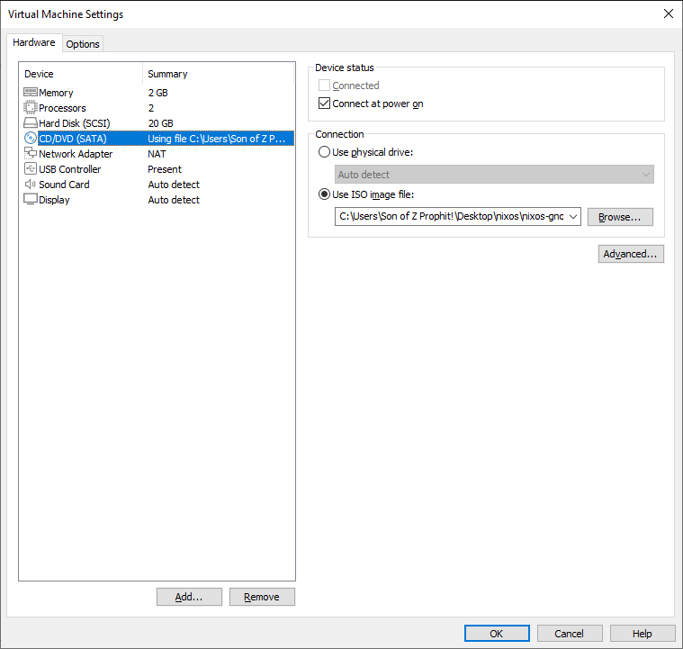

* This process was **complex and error-prone** for first-time users. 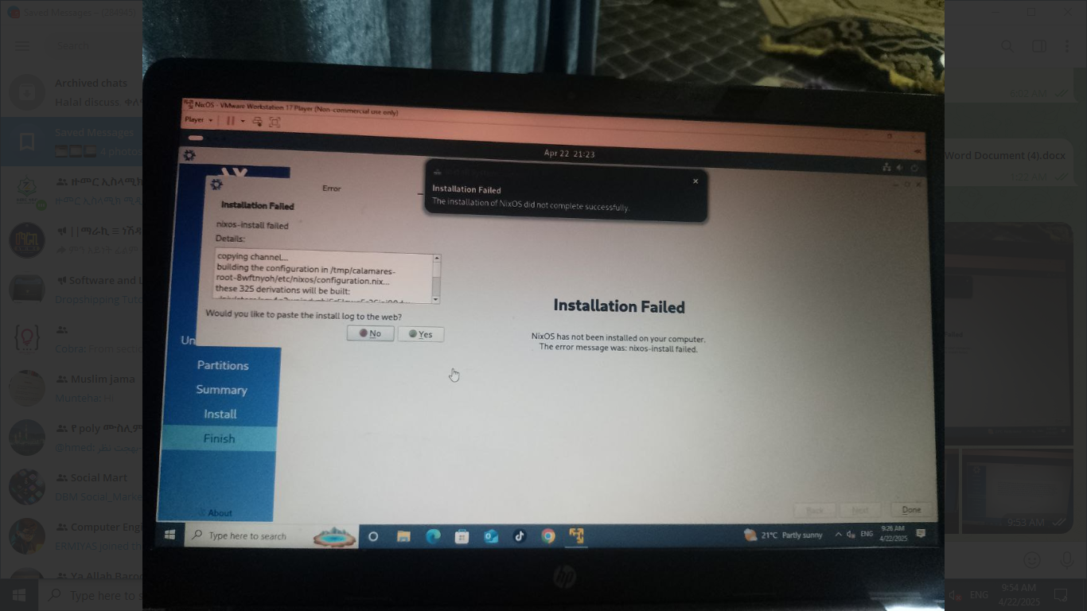

**Figure 3:** Terminal showing command-line installer or file editing screen

**Filesystem Support**

1. **ext4**  
   **Supported by NixOS:** Yes

**Reason:** ext4 is one of the most commonly used filesystems in Linux. It's very stable, well-tested, and suitable for daily usage. It's a safe bet for NixOS users, especially for the root partition due to its ubiquity, speed, and stability.

**Strengths:**

* + Journaling guarantees data consistency.
  + Excellent support in Linux distributions, including NixOS.
  + Excellent read/write performance.

**Weaknesses:**

* + Does not support advanced functionalities like snapshots or compression, which are available in other filesystems.

1. **Btrfs**  
   **Supported by NixOS:** Yes

**Reason:** Btrfs is a contemporary filesystem designed for snapshotting, compression, and data integrity via checksums. It is ideal for users who need flexible storage management or rolling back system changes.

**Strengths:**

* + Snapshot and rollback support.
  + Integrated data integrity through checksumming.
  + Support for compression and deduplication.

**Weaknesses:**

* + Performance overhead with some workloads.
  + Stability issues on older kernels.

1. **ZFS**  
   **NixOS Support:** Yes (but requires manual setup)

**Reason:** ZFS is a high-performance filesystem that includes native RAID, compression, and data integrity checking. However, due to licensing issues (CDDL), it is not included in the default NixOS kernel and requires manual setup.

**Pros:**

* + High-level features like RAID, compression, and snapshots.
  + Excellent data integrity based on checksums.

**Cons:**

* + Requires manual setup and installation.
  + More resource-intensive than ext4.
  + Licensing limitations.

1. **NTFS, FAT32, exFAT**  
   **Supported by NixOS:** Yes (with additional packages)

**Reason:** These are default filesystems for external devices or for compatibility with Windows systems. NixOS can access these filesystems via packages like ntfs-3g for NTFS and exfat-utils for exFAT.

**Benefits:**

* + Cross-platform compatibility, especially with Windows systems.
  + NTFS is typically used on large external drives or Windows-formatted drives.

**Drawbacks:**

* + Not optimized for Linux; lacks journaling or snapshot features.
  + Partial performance in some scenarios.

1. **HFS+ and APFS**  
   **Supported by NixOS:** Yes (partial support)

**Reason:** These are the filesystems used by Apple macOS operating systems. While HFS+ is readable and writable in NixOS with the proper tools, APFS support is partial and may not be fully compatible.

**Pros:**

* + Enables interoperability with macOS operating systems.

**Cons:**

* + Partial support in Linux-based systems like NixOS.
  + APFS is harder to work with in Linux distributions.

**Why Root with ext4?**  
ext4 was chosen as the root partition because it is:

* Stable
* Well-supported across Linux distributions, making it the most secure solution for NixOS’s root partition.

**Advantages of NixOS:**

1. **Declarative Configuration:**

NixOS uses a declarative configuration system. That is, your system configuration can be defined in a single file (/etc/nixos/configuration.nix). All the system settings are declared in this file, e.g., packages to install, services to start, users to create, etc.

* + **Why it's good:** This is particularly useful because it makes it easy to replicate or duplicate your configuration onto another system. If something goes wrong or you need to roll back to an earlier state of the system, restoring your configuration file can quickly restore the system's previous working state.

1. **Atomic Upgrades:**

One of the best features of NixOS is atomic upgrades. When upgrading packages or the operating system itself, the system makes an immutable snapshot. If the upgrade fails, the system automatically reverts to its previous state.

* + **Why it's good:** This greatly reduces the risk of system breakage, which is especially important for system administrators who need stability in their production environments.

1. **Strong Package Management:**

NixOS employs the Nix package manager, which is a very flexible package manager that gives you full control over the software installed on your system. It isolates environments to prevent software dependency issues.

* + **Why it's good:** You can manage multiple versions of a package and ensure compatibility without worrying about conflicting dependencies. This flexibility allows you to maintain different versions of software without interference between them.

1. **Rollback and Snapshots:**

NixOS allows you to take snapshots of the entire system or specific configurations. If you make a change that causes issues (e.g., a broken configuration or package), you can easily roll back to a previous working configuration.

* + **Why it's cool:** This ensures minimal disruption to your system, making it easy to experiment with different settings or configurations without the fear of permanently breaking something.

**Disadvantage of NixOS:**

1. **Sloping Learning Curve:**

Despite its strong features, NixOS is not beginner-friendly. Its declarative configuration system and use of the Nix package manager can be intimidating for users who are not familiar with Linux system administration.

* + **Why it's a disadvantage:** The lack of a graphical installer, user-friendly UI, and the need for manual configuration for most parameters make it challenging for beginners.

1. **Limited Software Availability:**

Although NixOS boasts an extensive package repository, some proprietary software or software from other Linux distributions may not be available. For example, certain commercial applications may require extra effort to install.

* + **Why it's a downside:** If you rely on specific software that is not available in the Nixpkgs repository or requires a complex installation process, this can be a hassle.

1. **Hardware Compatibility:**

Some newer or exotic hardware devices may be supported only partially out of the box. High-end graphics cards or cutting-edge Wi-Fi cards, for instance, may require manual configuration or installation of proprietary drivers not available in the NixOS repository.

* + **Why it's a limitation:** Users with exotic or bleeding-edge hardware may find it frustrating to get their devices working properly in NixOS, requiring more manual intervention or external driver sources.

1. **Performance Overhead:**

The declarative and transactional nature of NixOS's system configuration may introduce some performance overhead under certain conditions. However, for most standard workloads, this effect is minimal.

* + **Why it's a minus:** Under high-performance workloads or resource-constrained scenarios, this overhead could slightly affect the overall responsiveness of the system.

**Conclusion**

NixOS is one of the most innovative and versatile operating systems in the Linux ecosystem. Its declarative configuration paradigm reshapes system administration and maintenance, offering reproducibility, stability, and flexibility that surpasses traditional Linux distributions. The system is designed with the philosophy that everything, from package builds to service configurations, is handled as code within a single declarative file. This approach makes system configurations reproducible and easily reversible, making NixOS a powerful candidate for highly dynamic systems.

However, NixOS is not without its challenges. The learning curve and unfamiliarity with the system for users accustomed to traditional Linux distributions or desktop operating systems can be significant barriers. New users may struggle with the nuances of Nixpkgs, the Nix package manager, and the declarative programming style, leading to longer setup and debugging times. Additionally, the lack of complete out-of-the-box support for certain hardware components and software stacks, particularly proprietary drivers and commercial software, can hinder adoption, especially for users reliant on such technologies.

**Strengths:**

1. **Declarative Configuration and Version Control:**

NixOS allows users to transform their systems into declarative configurations, where the system state is fully defined in a configuration file. This is particularly beneficial for system rebuilding, upgrading, rolling back, and ensuring consistency and integrity. Every change can be tracked, reverted, or copied, making NixOS ideal for development environments where reproducibility is critical.

1. **Atomic Upgrades and Rollbacks:**

One of the standout features of NixOS is its atomic upgrade process. Upgrades and installations are treated as transactions, and if an upgrade fails, the system automatically reverts to the last working state. This ensures that system administration is risk-free and stable, particularly for production environments where uptime and stability are paramount.

1. **Package Management with Nix:**

The Nix package manager provides fine-grained control over software environments. It isolates dependencies, preventing conflicts between different programs. Unlike traditional package managers that may cause dependency hell, Nix allows multiple versions of software to coexist peacefully, making it particularly useful for users with complex or specialized software needs.

1. **Rollback and System Snapshots:**

NixOS takes system snapshots to a whole new level. Not only can files be restored from a snapshot, but the complete system state and all settings can also be reverted to a previous version. This level of recoverability is particularly useful for system administrators managing critical infrastructure who want to ensure a safety net when upgrading or changing system configurations.

**Challenges:**

1. **Learning Curve:**

The declarative nature of NixOS is unfamiliar to most Linux users accustomed to traditional package managers like APT or YUM. The process of understanding configuration files and managing system services can be difficult for beginners, making NixOS a less accessible choice for new users.

1. **Hardware Compatibility:**

While NixOS excels in many areas, installing it on specialized or newer hardware can be challenging. Devices such as graphics cards, wireless adapters, and other new hardware may not have out-of-the-box support. This is particularly problematic for users who rely on proprietary drivers or hardware that is not well-supported by the Linux community.

1. **Software Ecosystem:**

Although Nixpkgs offers a massive repository of packages, certain commercial or proprietary software may not be available or may require unique installation procedures. This limitation could hinder NixOS's adoption among users dependent on non-open-source software or specific proprietary applications.

1. **Usability and Accessibility:**

The lack of a graphical installer and a point-and-click system configuration interface can make NixOS intimidating for new users. The heavy reliance on configuration files for even simple tasks like package installation or user management is not as user-friendly as some other distributions, which could deter those new to Linux.

**NixOS's Future:**

NixOS has a promising future as it continues to grow. Its declarative model will become increasingly valuable as organizations adopt DevOps culture and demand systems that are not only stable but also easily reproducible. The trend towards containerization and microservices architecture plays to NixOS's strengths, as it is designed for immutable infrastructure.

The Nix package manager's environment isolation offers unparalleled control over dependencies, and as the Nixpkgs repository expands, NixOS will likely become a go-to choice for programmers looking to create highly customized and fine-tuned configurations.

To become more mainstream, NixOS will need to improve in a few key areas:

* **Improved Hardware Support:** Closer collaboration with kernel developers and hardware vendors could enable better out-of-the-box support for new hardware.
* **User Experience:** Improving documentation, simplifying installation instructions, and potentially developing a GUI configuration tool would make NixOS more accessible to a broader audience, from individual users to business environments.
* **Package Availability:** NixOS should continue expanding its Nixpkgs repository and aim to include more commercial software, games, and proprietary software.

**Final Thoughts:**

In conclusion, NixOS is a robust and innovative operating system with a unique approach to system management. Its declarative model, atomic upgrades, and rollbacks make it an excellent choice for production environments, particularly in cloud-native and DevOps settings. However, its steep learning curve, complexity, and limitations in hardware and software support may discourage new users and limit its adoption in certain use cases. As NixOS continues to evolve, it has the potential to become a mass-market operating system with tremendous value for power users, system administrators, and development teams.

### Future Outlook of NixOS:

NixOS is emerging as a revolutionary operating system, gaining popularity due to its unique declarative configuration, immutability, and reproducibility. As the technology landscape moves towards cloud-native solutions, automation, and containerization, NixOS's features align perfectly with these trends, especially in DevOps and production environments. The future of NixOS will be shaped by these key trends and developments:

#### Greater Adoption in Enterprise Environments:

The declarative configuration model of NixOS makes it an ideal choice for organizations that require stable and reproducible systems across multiple environments (development, staging, production). With atomic upgrades and rollbacks, businesses can ensure that system changes are safe, reversible, and reliable.

* **Why it matters:** NixOS's focus on reliability, zero-downtime, and scalability makes it highly appealing for large organizations managing cloud-native infrastructures.
* **Example:** Companies using Kubernetes and containerized environments can leverage NixOS to ensure consistent deployments and immutable infrastructures across various environments.

#### Growth in Cloud-Native and Containerized Environments:

As more organizations embrace cloud-native architectures and adopt containerization (e.g., Docker, Kubernetes), NixOS’s ability to manage immutable systems and reproducible configurations becomes increasingly valuable. NixOS is well-suited for microservices and container orchestrations, ensuring consistency across distributed systems.

* **Why it matters:** NixOS’s declarative model directly supports the containerization trend, where reproducibility and immutability are key.
* **Example:** NixOS can be used to deploy microservices where system configurations and software dependencies are explicitly defined, ensuring that the environment is the same across all instances.

#### Ongoing Development of Nixpkgs Repository:

The Nixpkgs package repository is the backbone of NixOS. As the repository continues to grow, it will provide users with an increasingly rich set of software packages and tools, making NixOS even more powerful and flexible.

* **Why it matters:** The continuous development of Nixpkgs will attract more system administrators and developers, as they can depend on a wide range of well-maintained packages that work seamlessly with the Nix package manager.
* **Example:** Developers who require specific versions of programming languages or frameworks will appreciate the ability to manage dependencies with high precision without worrying about conflicts, which is common with traditional package managers.

#### Hardware Compatibility Improvements:

Although NixOS works well with many types of hardware, there is room for improvement, especially with newer and specialized hardware. Greater collaboration with hardware manufacturers and kernel developers could enhance NixOS's support for a broader range of devices, particularly those with proprietary drivers.

* **Why it matters:** Expanding hardware compatibility will allow NixOS to reach a wider audience, including users with specialized or cutting-edge hardware.
* **Example:** NixOS could improve support for newer graphics cards, Wi-Fi adapters, and emerging technologies like 5G devices or edge computing hardware.

#### Usability and User Experience:

Currently, NixOS is more suited for developers and experienced users due to its steep learning curve. For broader adoption, improving the user experience (UX) and making the system more accessible to non-technical users is crucial.

* **Why it matters:** Making NixOS more user-friendly would enable more users, especially those from non-technical backgrounds, to adopt the OS. This would significantly expand its potential user base.
* **Example:** A graphical installation tool and a user-friendly configuration utility would allow users to install and manage their systems without needing to manually edit configuration files.

### Recommendations for NixOS:

As NixOS continues to evolve, it can further enhance its appeal by addressing a few key areas. Here are some actionable recommendations:

#### 1. **Improve Documentation and Community Support:**

While NixOS is gaining traction, it still lacks the extensive documentation and tutorial resources that other popular Linux distributions offer. For broader adoption, NixOS should focus on creating comprehensive documentation and easy-to-follow tutorials.

* **Why it's important:** Better documentation will reduce the entry barrier for new users, making it easier for them to navigate the system and utilize its powerful features.
* **Example:** Video tutorials and detailed manuals could help new users install NixOS, configure their systems, and troubleshoot common issues.

#### 2. **Offer a Graphical User Interface (GUI) for Configuration:**

Although the declarative configuration model is powerful, it can be intimidating for new users to manually edit configuration files. Introducing a GUI tool would provide a more accessible way to manage system settings.

* **Why it's necessary:** A GUI would open up NixOS to users who are not familiar with command-line interfaces, making the system more approachable.
* **Example:** A NixOS Control Panel could enable users to install software, manage services, and tweak system configurations using a simple, point-and-click interface, while still maintaining the flexibility of the declarative system.

#### 3. **Improve Hardware Support and Certification:**

To increase adoption among personal and enterprise users, NixOS needs to enhance support for specialty hardware and proprietary drivers. Working with hardware manufacturers to ensure broader device compatibility is critical.

* **Why it matters:** Improved hardware support would make NixOS more appealing to users who require seamless integration with their hardware.
* **Example:** By certifying support for popular hardware like Nvidia graphics cards, Wi-Fi adapters, and peripheral devices, NixOS could provide a more user-friendly experience for everyday users.

#### 4. **Boost Software Availability:**

While Nixpkgs offers an extensive range of packages, there is still room for improvement, especially in terms of commercial and proprietary software. Encouraging third-party developers to package their applications for Nixpkgs would increase software availability.

* **Why it matters:** A broader range of software will make NixOS a more versatile option for a wider range of users, including those who rely on non-open-source applications.
* **Example:** NixOS could provide easy-to-follow instructions for installing commercial software like Adobe Photoshop or Microsoft Office, which would appeal to users outside of the open-source ecosystem.

#### 5. **Focus on Education and Enterprise Adoption:**

NixOS should target the academic and enterprise markets, promoting the adoption of immutable infrastructure and containerization. Offering training programs, certifications, and enterprise-level solutions will help establish NixOS as a mainstream option for corporate environments.

* **Why it matters:** NixOS's declarative advantages make it well-suited for enterprise environments, where stability, reproducibility, and automation are crucial.
* **Example:** NixOS could partner with universities and businesses to create workshops, bootcamps, and certifications focused on immutable systems and cloud-native infrastructure, positioning itself as a leader in modern IT practices.

**What, Why, and How of Virtualization in Modern Operating Systems**

### What is Virtualization? **What is Virtualization in Contemporary Operating Systems?**

Virtualization is a method of technology that enables multiple virtual copies of operating systems (virtual machines or VMs) to run on a single physical machine. Each virtual machine operates as though it is a completely independent computer, with its own operating system, software, and allocated resources, all running on the underlying physical hardware of the host system.

### **Why Virtualization in Contemporary Operating Systems?**

1. **Resource Efficiency**: Virtualization allows multiple operating system instances to run on a single piece of hardware. This maximizes the use of the available resources, reducing the need for multiple physical machines and enabling better resource management.
2. **Isolation and Security**: Virtual machines are isolated from each other, meaning that issues like crashes or security breaches in one VM will not impact others. This isolation is ideal for testing, development, and securely running multiple applications or services in different environments.
3. **Flexibility and Scalability**: Virtualization enables the management of multiple OS versions and configurations, offering flexibility in provisioning and scaling. New VMs can be quickly deployed, and they can be migrated between physical hosts without disruption.
4. **Cost Savings**: By consolidating workloads onto fewer physical machines, virtualization reduces hardware requirements and lowers energy consumption, making it a cost-effective solution for data centers and businesses.
5. **Snapshots and Rollbacks**: Virtual machines allow users to take snapshots of their system at a particular point in time. If a change causes issues, the system can be rolled back to a previous snapshot, which is extremely useful for testing and software upgrades.

### **How Virtualization Works in Modern Operating Systems?**

1. **Hypervisor (Virtual Machine Monitor)**: Virtualization is achieved through a component called the hypervisor, which sits between the hardware and the operating systems. There are two types of hypervisors:
   * **Type 1 (Bare-metal Hypervisor)**: This runs directly on the physical hardware, without needing a host OS. Examples include **VMware ESXi** and **Microsoft Hyper-V**.
   * **Type 2 (Hosted Hypervisor)**: This runs on top of an existing operating system, using the host OS’s resources. Examples include **Oracle VirtualBox** and **VMware Workstation**.
2. **Virtual Machines (VMs)**: A virtual machine operates as if it’s a full independent computer. Each VM runs its own operating system and is assigned virtualized resources (such as CPU, memory, and disk) from the hypervisor. VMs are flexible and can run different operating systems, such as running a Linux VM on a Windows host.
3. **Virtual Hardware**: The hypervisor presents virtualized hardware to each VM, which includes virtual CPUs, memory, network adapters, and disk storage. From the perspective of the VM, it operates just like a physical computer, even though it’s running on virtualized hardware.
4. **Resource Allocation**: The hypervisor allocates physical hardware resources like CPU cores, RAM, and disk space to the VMs. This allocation is dynamic, allowing the hypervisor to adjust resource distribution based on the changing needs of the VMs.

### **Summary**:

In short, virtualization allows multiple independent operating systems to run on the same physical hardware, offering key benefits such as **enhanced resource utilization**, **improved security**, **cost efficiency**, and **easier management**. Virtualization is a fundamental technology for modern cloud computing, server consolidation, and efficient system administration.

Top of Form

Bottom of Form

Implementation of system call ftruncate() on nix os

To implement and test the ftruncate() system call inside the NixOS operating system running in a virtual environment. This system call will be used to resize an existing file to a shorter size, verifying POSIX compliance within NixOS.

### 🛠️ **Step-by-Step Implementation on Nix**

#### 🧱 **Step 1: Open Terminal**

* Press Super (Windows key) → type Terminal → Press Enter. 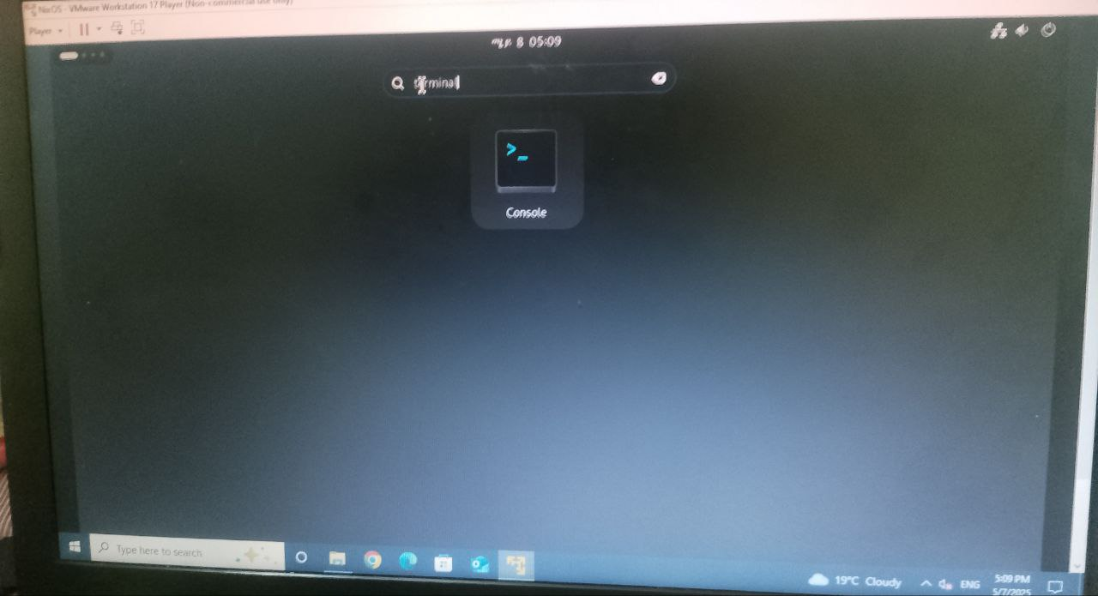

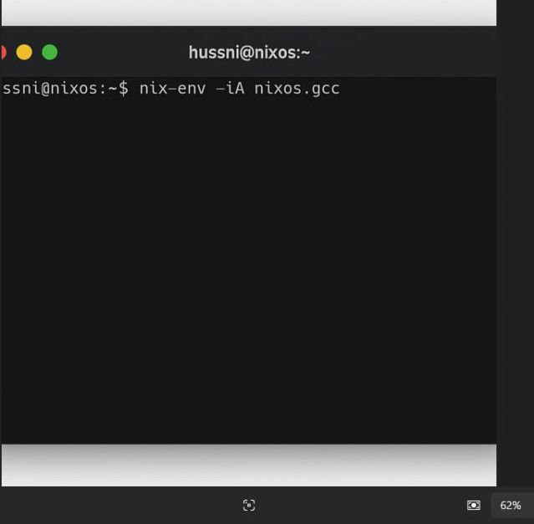

#### 🧾 **Step 2: Install GCC Compiler (if not installed)**

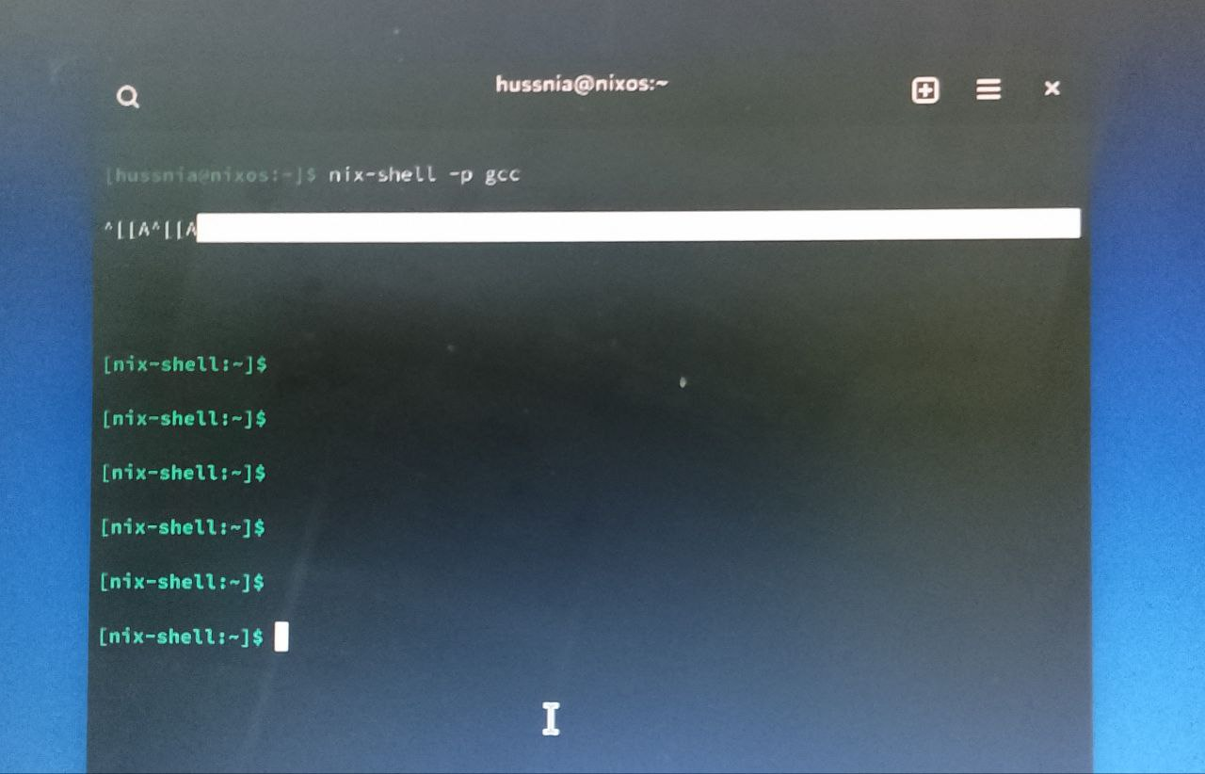

|  |
| --- |
| nix-env -iA nixos.gcc |

This command installs the GCC compiler which is necessary for compiling C programs in NixOS.

#### 📄 **Step 3: Write the C Program**

1. In the terminal, open a text editor (e.g., nano):

|  |
| --- |
| nano ftruncate_example.c |

1. Paste the following code:

c

|  |
| --- |
| #include <stdio.h>  #include <stdlib.h>  #include <fcntl.h>  #include <unistd.h>  int main() {  const char *filename = "example.txt";  // Open file with read/write access, create it if it doesn't exist  int fd = open(filename, O_RDWR | O_CREAT, 0644);  if (fd < 0) {  perror("open");  return 1;  }  // Write initial data  write(fd, "Hello from OSSP project using ftruncate!\n", 41);  // Truncate to 10 bytes  if (ftruncate(fd, 10) == -1) {  perror("ftruncate");  close(fd);  return 1;  }  printf("File has been truncated successfully.\n");  close(fd);  return 0;  } |
|  |

### 

### **Explanation for OSSP Report**

In this implementation, the ftruncate() system call was used to shorten a file to 10 bytes. This was done inside the NixOS virtual environment, demonstrating compliance with POSIX standards. We used the open(), write(), ftruncate(), and close() system calls defined in <fcntl.h> and <unistd.h>. The successful output and reduced file size confirm the functionality of ftruncate() in NixOS.

### 📌 Optional: Automation with Bash Script

Create a script to run all the steps automatically:

1. Create script file:

bash

CopyEdit

nano run_ftruncate.sh

1. Paste:

bash

CopyEdit

|  |
| --- |
| #!/bin/bash gcc ftruncate_example.c -o ftruncate_example  ./ftruncate_example  ls -l example.txt  cat example.txt |

|  |
| --- |
| chmod +x run_ftruncate.sh  ./run_ftruncate.sh |

1. Save and exit, then give permission:

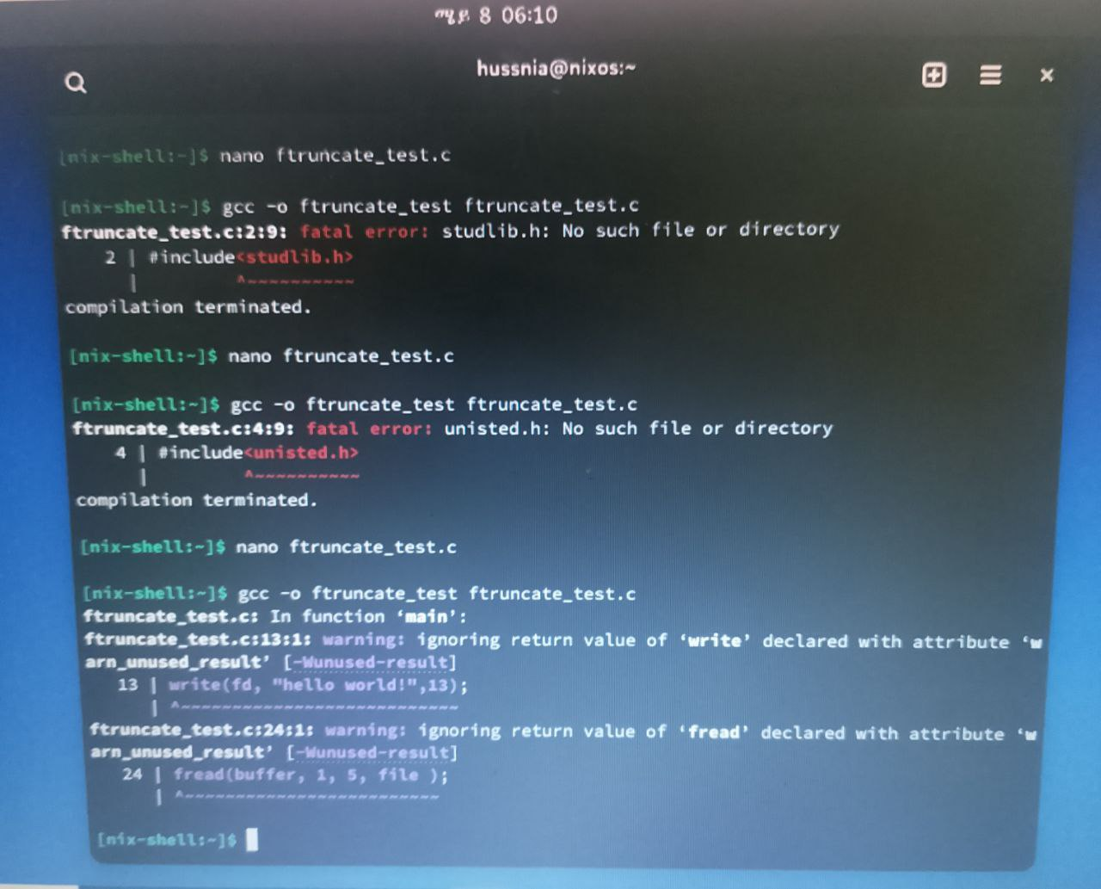

### 

### Thank you